Programme Note by Chris Darwin: please use freely for non-commercial purposes

**Ludwig van Beethoven (1770-1827) Piano Trio in C minor, Op.1 No.3 (1793/5)** *Allegro con brio*

*Andante cantabile con Variazioni*

*Menuetto & Trio Quasi Allegro*

*Finale: Prestissimo*

Beethoven's three Op.1 trios are dedicated to Prince Karl von Lichnowsky who had been generous to Beethoven after his arrival in Vienna. A composer and collector of Bach manuscripts, Lichnowsky had also been very generous to Mozart lending him a substantial sum of money, which Mozart was unable to repay. It has recently come to light that the Prince sued Mozart and, a few weeks before Mozart died, the court found in the Prince's favour and requisitioned half of Mozart's salary from the Imperial Court. Beethoven initially fared better and secured a substantial annuity from the Prince which was paid until the two had a furious quarrel in 1806 causing Beethoven, in turn, to sue Lichnowsky.

Before his Opus 1 was published by Artaria in 1795, Beethoven had already written at least 3 piano quartets, 2 piano trios and a wind octet. He probably began work on these Opus 1 piano trios in his home town of Bonn, but continued to work on them after his move to Vienna in 1792, where Haydn heard them performed the following year. Haydn advised Beethoven not to publish the C minor trio. Beethoven took offence, thinking Haydn jealous and ill-disposed to him, though Haydn said he was simply trying to protect Beethoven from what he thought would be a hostile public response. Nonetheless, Beethoven delayed publication and revised the trios, partly as a result of Haydn's remarks, but also to ensure good sales on the basis of his growing reputation. His efforts and guile were well rewarded with an initial subscription of 241 copies bringing in the equivalent of many thousand pounds today.

The Trios are rich in ideas (' *When I re-read the manuscripts I wondered at my folly in collecting into a single work materials enough for twenty*') and have many of Beethoven'scharacteristic trade-marks. In Beethoven’s hands the trio form moves beyond the traditional three-movement design of Haydn and Mozart: he adds a movement, casts the individual movements on a larger scale, and gives the strings, in particular the cello, a more independent role.

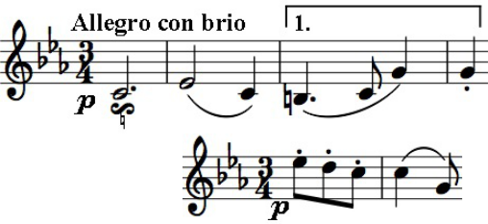

The C minor trio is the most powerful of the three, influenced by the *Sturm und Drang* movement of earlier decades. A sinister mood is set at the start in the introductory pause-filled first few bars but then

contrasted with a more hopeful staccato figure (illustrated) and with an optimistic second theme. At the start of the development Beethoven plays a characteristic trick, moving to the remote key of B major by

simply repeating a version of the third bar phrase (under 1.) down a semitone - bold and effective. That phrase is passed between the instruments building tension, and each motif is presented at different times in different moods swinging often violently from one to the other.

After the turbulence of the first movement, the *Andante cantabile* variations are altogether gentler. The initially worried *Menuetto* is relieved by rapid rising arpeggios in the piano and by its carefree *Trio* with cascading piano scales. Then we are back to the stormy emotions of the first movement in the headlong *Finale* opening with more arpeggios but in a very different, somewhat frantic mood. Relief comes with a sunny theme related to the opening two bars of the first

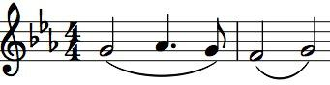

movement (illustrated). But Beethoven works his moody magic on this and the opening theme until with pianissimo ascending scales the music simply evaporates.