**Program note by Chris Darwin: use freely for non-commercial purposes**

**Ludwig van Beethoven (1770-1827) Piano Trio in B flat Op. 97 ‘Archduke’ (1811)**

*Allegro moderato*

*Scherzo & Trio: Allegro*

*Andante cantabile ma però con moto*

*Allegro moderato - Presto*

Beethoven's Op 97 '*Archduke*' Trio of 1811 is the middle one of a remarkable sequence of three

chamber works. It comes between the Op 95 '*Serioso*' String Quartet of 1810 and the glorious Op 96

Violin Sonata of 1812. The Trio's dedicatee Archduke Rudolph was the Emperor Leopold II's

youngest son, a piano and composition pupil of Beethoven. Their relationship was close and long-

lasting: Rudolph not only admired Beethoven and tolerated his foibles but, together with the Princes

Kinsky and Lobkowitz, contracted to provide Beethoven with an annuity so that '*the necessities of*

*life shall not cause him embarrassment or clog his powerful genius*'. During Napoleon's occupation

of Vienna in 1809 Rudolph had sought sanctuary in Hungary, prompting Beethoven's regretful

'*Lebewohl*' Piano Sonata. Following Napoleon's departure, Rudolph returned early in 1810, but by

then Beethoven had other problems: love and money. First, Therèse Malfatti turned him down. He

wrote self-pityingly to his friend Ignaz von Gleichenstein, who had introduced them, *'For your*

*poor B, no happiness can come from outside. You must create everything for yourself in your own*

*heart; and only in the world of ideals can you find friends'.* Incidentally, as a farewell present he

gave Therèse a little Bagatelle, later published with the probable misattribution of *Für Elise*.

Second, because of inflation following the Napoleonic Wars, Beethoven's annuity declined in

purchasing power (though the kindly Rudolph later agreed to reinstate the real value of his share).

Whereas the Op 95 '*Serioso*' String Quartet reflects these traumas and tensions, the '*Archduke*' Trio miraculously rises above them. The work opens with a spacious melody first on the piano, then on the violin (*illustrated*).

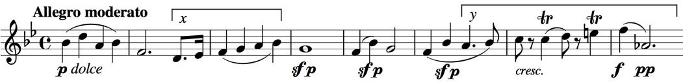

The opening bar figures prominently in the development, while the

third bar material (under *x*) yields a novel pizzicato dialogue between the two strings, an example of the new textures that Beethoven creates in this work.

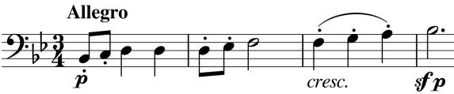

The opening of the *Scherzo* (*illustrated*) begins another string dialogue, using material related to that under *x* and *y* in the first example. Its lightness contrasts with the creepy gloom of the opening of the Trio.

The Andante is one of Beethoven's most sublime: a set of variations on a miraculously extended theme. The opening, though richly scored, is marked *piano semplice* and *piano dolce* dissuading the players from overindulgence. Three variations increase in movement and complexity until the fourth reverts to quiet contemplation of the original theme by the individual instruments. This reverie is rudely broken and the piano suggests something quite different which the strings, maybe against their better judgment, come round to agreeing to. What follows is something of a piano concerto, perhaps acknowledging the Archduke's skill. The violin is banished to its lower register, and the cello is only occasionally allowed to shine high. But the piano has a ball: *Presto, Più Presto. Fine.*