**Programme notes by Chris Darwin. Use freely for non-commercial purposes**

**Ludwig van Beethoven (1770-1827) Violin Sonata in G Op 96 (1812)**

*Allegro moderato*

*Adagio espressivo*

*Scherzo. Allegro*

*Poco Allegretto*

During the years 1810-12 Beethoven produced three remarkable chamber works: in 1810 the Op 95 '*Serioso*' String Quartet, in 1811 the Op 97 '*Archduke*' Piano Trio, and in 1812 today's glorious Op 96 Violin Sonata. The dedicatee of the two latter works was Archduke Rudolph, youngest son of the Emperor Leopold II and a piano and composition pupil of Beethoven. Their relationship was close and long -lasting: Rudolph not only admired Beethoven and tolerated his foibles but, together with the Princes Kinsky and Lobkowitz, had contracted to provide Beethoven with an annuity so that 'the necessities of life shall not cause him embarrassment or clog his powerful genius'. During Napoleon's occupation of Vienna in 1809 Rudolph had sought sanctuary in Hungary, prompting Beethoven's regretful '*Lebewohl*' ('*Les Adieux*') Piano Sonata.

However, Rudolph, the dedicatee, is not the focus of this G major violin sonata. That

privilege arguably belongs to Antonie Brentano (née Birkenstock), the intended recipient of

Beethoven's long, impassioned 'Immortal Beloved' letter which was contemporary with the

sonata. Unhappily married to a workaholic Frankfurt banker, Antonie had fallen for

Beethoven, and he for her. To her, Beethoven '*walked like a god among*

*mortals...guileless, straightforward, wise and wholly benevolent...[with a] soft heart (and]*

*ardent nature'.* For his part Beethoven improvised for her in the next room when she was

unwell and *c*omposed settings of a short poem *An die Geliebte.* Antonie's return to

Frankfurt in July 1812 prompted not only the Op 96 sonata, but also *An die ferne Geliebte,*

*(To the distant loved one)* Beethoven's impassioned Op 98 song cycle.

A third personality contributes to the sonata's arrival: the virtuoso violinist Pierre Rode who was visiting Vienna in December 1812. He was invited to give its first performance together with Archduke Rudolph on piano. Rudolph had prepared punctiliously for the performance, but Rode approached it with an arrogance bred of a diet of virtuosic trivia. The performance was a disappointment, although discerning critics saw through Rode to the profound and intimate wonders of the music.

The sonata opens, like Beethoven's previous sonata, the 1803 '*Kreutzer*', with the solo violin, but the mood could not be

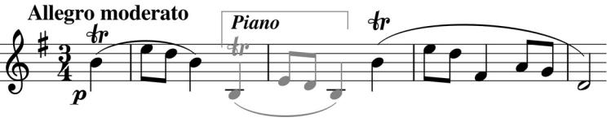

more different. Where the earlier sonata is dramatically arresting, here we have a tender request, encouragingly echoed by the piano,

and then elaborated by the violin (*illustrated*). The mood is sunny, the two instruments making beautiful music - Beethoven's '*soft heart*' never more on his sleeve.

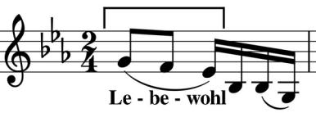

The slow movement begins with a profound and slow hymn, whose last phrase (*illustrated*), echoed by the violin, starts with the three notes of the *Lebewohl* motif. The departure is now that of Mrs Brentano for Frankfurt rather than of Archduke

Rudolph for Hungary. This intense and reflective movement leads straight into a contrasting, short cheerful *Scherzo* whose*Trio* theme exultantly arches up and back through two octaves.

The last movement, based on variations, starts blandly with a modestly rustic tune, but beware of Beethoven bearing innocuous themes. After building the tension over four variations, the tempo drops abruptly to

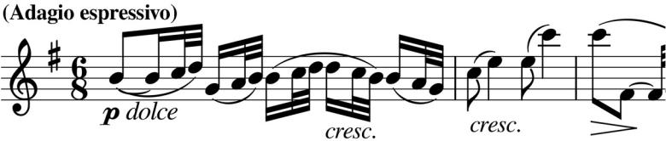

* serious *Adagio espressivo*. The piano and violin alternately accompany each other's intense reflections separated by brief piano

cadenzas. Their dialogue leads to this heart-rending passage on the violin (*illustrated*), before we are released into a determinedly energetic *Allegro*. A brief, poignant, *Adagio* reminiscence is brusquely dismissed by the final *Presto* eight bars.