**Ludwig van Beethoven (1770-1827) Quartet in F minor, Op 95** (***Quartett Serioso*)**

**(1810)**

*Allegro con brio*

*Allegretto ma non troppo*

*Allegro assai vivace, ma serioso - Più Allegro Larghetto espressivo – Allegretto agitato – Allegro*

*“NB. The Quartet is written for a small circle of connoisseurs and is never to be performed in public... Should you wish for some Quartetts for public performance, I would compose them to this purpose occasionally”*. So wrote Beethoven in 1815 to Sir George Smart, his London promoter, not only anticipating the sophistication of this morning's audience but also safeguarding the quality of performance (the aristocracy hired better players) and trying to insulate himself from uncomprehending rejection. The F minor is a “serious” quartet: “*not a ‘pretty’ piece, but it is terribly strong - and perhaps rather terrible… Everything unessential falls victim, leaving a residue of extreme concentration, in dangerously high tension*” (Joseph Kerman). The *serioso* quartet is an isolated bridge between the middle quartets (Rasumovsky quartets and Op 74 “Harp”) of the 1800s, and the final set of late quartets from 1825. The work experiments with various techniques that will appear in the late quartets and is contemporary with the *Egmont* overture and with Napoleon's 1809 invasion of Vienna.

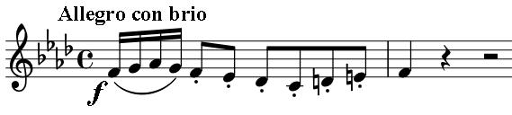

Beethoven challenges the listener from the start with this grim unison outburst and pause, answered by 3-bars of angry, spiky octave leaps in the dominant (C minor). The

original outburst is repeated on the cello up a semitone and in the major (a “Neapolitan” modulation). It is answered by a more conciliatory slow theme from the violin, but ominous rapid ascending figures in the cello force us back to the initial outburst. And that is just the first 17 bars: enough to challenge even aristocratic connoisseurs. This brutally condensed, tempestuous movement is all over in less than 5 minutes.

The *Allegretto* inverts the threatening, ascending scales of the first movement to a gentle stepping descent from the cello, introducing a calm theme related to that of the first movement. The viola then

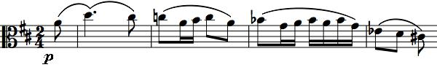

introduces a new theme, which is taken up as a fugue.

The third movement, based on the *Scherzo* form, starts, like the first, with an abrupt, angry challenge, just one bar and a pause; it is repeated, more demandingly, followed by a descending scale in dotted rhythm on a sinister crescendo.

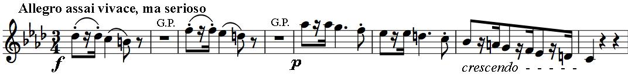

This angry section is developed and repeated, but then dissolves into a tranquil slow melody from the second violin, caressed by first violin arpeggios, initially in the minor, then the major. The contrast is repeated, but finally anger, at a faster tempo, slams the door on the movement.

All seems well with the world in the expressive slow introduction to the last movement. But this optimism is threatened by the worried

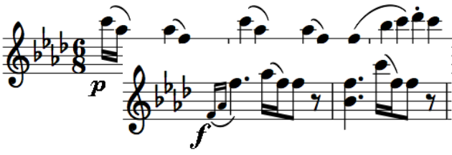

agitation of pairs of *piano* semiquavers from

the first violin. The threat level ratchets up on subsequent returns of this figure with an increasingly agitated accompaniment, and terrified octave and tenth leaps in the first violin. But then, a more hesitating, *pianissimo*, return of the figure heralds a *forte*, reassuring modification (illustrated *right*). The tempo increases to *Allegro*, the key shifts to the major and the threat is forgotten in a final triumphantly rising scale.