Programme notes by Chris Darwin – use freely for non-commercial purposes

**Ludwig van Beethoven (1770-1827) Piano Trio in E-flat Op.70 No.2 (1808)** *Poco sostenuto – Allegro ma non troppo Allegretto*

*Allegretto ma non troppo*

*Finale: Allegro*

1808 saw Beethoven composing at full power: his Fifth and Sixth Symphonies, the Choral Fantasia, the A major cello sonata as well as the two Op 70 piano trios all come from this year. The cello sonata and the piano trios seem to have been part of a conscious decision by him to revisit the chamber music forms with which he had made such an impact shortly after his arrival in Vienna.

The two Op 70 piano trios are of very different worlds – both represented in Beethoven's mid-1808 sketchbook: the first trio (nicknamed the Ghost) inhabits the violent and supernatural world of a proposed opera on Macbeth (the Ghost being Banquo's), the second the warm humanity of the Pastoral Symphony. Both trios are dedicated to the Hungarian Anna Maria, Countess Erdődy. She was one of Beethoven's longest-lasting friends, a faithful promoter of his music and an initiator of the legal contract that gave him an annual income. Her numerous exchanges of letters with Beethoven shared deep philosophical ponderings together with mutual grumblings about their respective ill-health. A proper friend!

This genial, E-flat trio was probably written with the Countess in mind, both because of specific thematic links (such as Croatian folk music heard with the Countess in Hungary), but also more generally because of the unusually affectionate nature of much of the music.

As often in middle Beethoven, the introduction searches for the right key: the cello proposes C minor with a little U-shaped phrase, the violin F minor, the piano Bb major before we land on the home key of Eb and a short piano cadenza leads us into the main *Allegro*. Soon the cello declaims a sing-it-from-the-

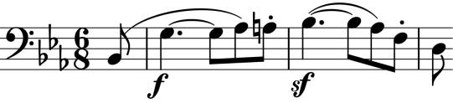

rooftops inverted U-shaped theme (*illustrated*) while the piano exuberantly hammers the accompaniment. But, not one to waste good material, Beethoven

springs a surprise by unexpectedly bringing back the slow introductory motif in the new tempo as a bridge into another group of cheerful tunes.

The two middle movements are perhaps unique in Beethoven's chamber music in both being *Allegrettos*. The first *Allegretto* is also unusual in consisting of variations on two contrasting dance themes, both with a Hungarian flavour: the first poised and in the major, the second coarser and in the minor. The second *Allegretto (ma non troppo)* movement is perhaps the most affectionate of the whole

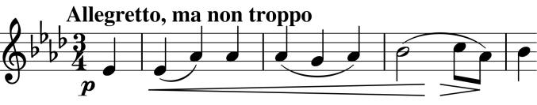

work: an ardently romantic song (*illustrated*) is reiterated over and over again within an

extended minuet and trio structure, never palling in its charm.

All three players get a chance to show off in the tirelessly exuberant last movement, which was inspired, according to Carl Czerny, by a galloping horse. The horse must keep on galloping according to Beethoven's instructions to his publishers: *'If there is anywhere a ritardando then remove it … - there should be no ritardando in the whole movement'*.

Acknowledgment: My debt to Angus Watson's excellent book '*Beethoven's Chamber Music in Context'* will be obvious if you read it.