**Program note by Chris Darwin: use freely for non-commercial purposes**

**Ludwig van Beethoven (1770 - 1827) String Quartet in F, Op 59 No 1 (Razumovsky)**

**(1804)**

*Allegro*

*Allegretto vivace e sempre scherzando*

*Adagio molto e mesto*

*Thème russe: Allegro*

The Razumovsky quartets were a revolution in quartet writing. *'Oh they are not for you, but for a later age'* Beethoven told an Italian violinist who found them incomprehensible. InJoseph Kerman's words '*It is probably not too much to say that Op. 59 doomed the amateur string quartet.'* The conversation between equal players of Haydn, Mozart and even Beethoven in his earlier Op 18 quartets here gives way to *'the heroic discourse of the symphony'* - and no ordinary symphony at that: the Op 59 quartets were written shortlyafter the third, *Eroica* Symphony.

The commission for them was from Count Andreas Razumovsky, the Russian ambassador to Vienna. His father had risen from humble origins, thanks in part to his fine singing voice, to be one of Catherine the Great's favourite lovers. Elevation to the nobility and to the rank of Field Marshall followed, together with a vast estate and aristocratic wife to match. There is nothing like music to lubricate social mobility! Son Andreas trained on a British warship for the Imperial Navy before joining the diplomatic service. As well as being vastly wealthy, thanks to his father's vocal and amatory virtuosity, he was also a very able second violinist in his own quartet. The first fiddle was Ignaz Schuppanzigh - friend, inspiration and perhaps also violin teacher to Beethoven. As well as playing with the Count, Schuppanzigh had formed his own professional quartet in 1804 in order to give public quartet concerts - a radical new departure. This accomplished quartet may have encouraged Beethoven to stretch his technical demands on the players to match his more ambitious musical conceptions. Schuppanzigh's quartet certainly took Beethoven's new works seriously, learning from bitter experience that all his new works were challenging.

The premier of the three Razumovsky quartets, or *'violin quartets'* as Beethoven described them to his publisher, was respectfully received in the press: *'deep in thought and well worked out, but not generally comprehensible'. T*hree months later however we hear that the same quartets *'have become more and more popular'*. It would be rare for contemporary audiences now to accommodate so rapidly to new works. Although the audiences were not large, they did consist of *'very zealous and attentive music lovers'*. As, of course, now.

The F major quartet lasts an unprecedented 40 minutes, sharing the expansive length of the Eroica Symphony. Even more remarkably, Beethoven's notebooks show that he originally intended, as is usual, to repeat the initial, exposition part of the first movement. He then decided to forgo the repeat, fooling us with 4 bars that are indeed identical to the opening but then swerving away. He also had plans to repeat the second part of the first movement and indeed a substantial part of the *Scherzo* and a small part of the *Finale*.

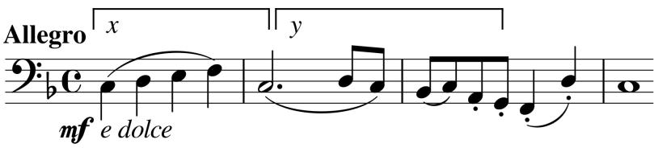The quartet's opening theme (illustrated) makes you wish you were a cellist (even just an amateur one) as it gradually unfolds over harmonically almost static repeated quavers. The theme contains

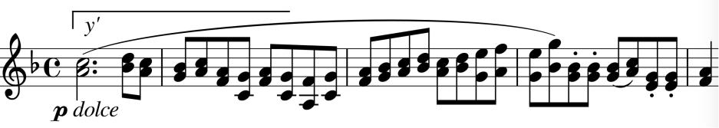

two elements (labelled *x* & *y*) that inspire several later developments, such as the y-based theme with the two

violins in thirds (illustrated). The exposition's richness - smooth leisurely themes contrasting with lively and wide-ranging triplets and arpeggios – is matched by a wonderful long development at the end of which the first violin triplets up *piano* to a top Bb, then B, then C heralding the return of the F major first theme, but then Beethoven side-steps into another theme and swerves through some unexpected keys before finally allowing the recapitulation to start.

In contrast to the lyrical richness of the first movement, the second, *Scherzo* movement starts as pure rhythm, *piano* on the cello (illustrated), with a lively fragmentary answer

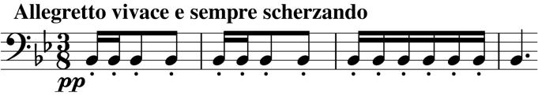

from the second violin. Not much to go on, but enough for Beethoven to provide us with a remarkably long and witty bout of musical ball-tossing. The slow movement – very slow and sad – uses the high register of the cello with keening poignancy and ends with a *piano* cadenza from the first violin whose final trill leads us into the "Russian theme" (perhaps at the request of Razumovsky) of the finale. Energetic and emotionally more straightforward, the movement presses on relentlessly, only briefly pausing to reflect in a dying-away *Adagio*, before racing the last 9 bars to the finish.

Angus Watson's book '*Beethoven's Chamber Music in Context'* was helpful in preparing these notes.