Program Notes by Chris Darwin. Please use freely for non-commercial purposes.

**Ludwig van Beethoven (1770-1827) Sonata for Piano and Violin Op 30 No 1 in A (1802)**

*Allegro*

*Adagio molto espressivo*

*Allegretto con Variazioni*

In April 1802, on the advice of his doctor, Johann Schmidt, Beethoven retired for a six month stay to the village of Heiligenstadt in the Vienna woods. Dr Schmidt hoped that its mineral baths and quiet would alleviate the deafness and tinnitus that for the past six years had increasingly plagued Beethoven. Initially things went well. Beethoven was optimistic and spectacularly creative: he finished the second symphony, rapidly drafted the three Op 30 violin sonatas, and continued with the three Op 31 piano sonatas and two sets of piano variations. But then, in October, the inevitable truth emerged that his hearing was not improving. He despaired and wrote a long, deeply personal letter to his two brothers, Carl and Johann to be opened after his death – the so-called *Heiligenstadt Testament*. In it he explained the wretchedness of his affliction and how he would have killed himself were it not *'impossible to me to leave this world before I had produced all that I felt capable of producing'*.

The Op 30 violin sonatas reflect Beethoven's earlier optimism. The A major sonata is the most serene of the three, somewhat similar in mood to his last violin sonata Op 96. Curiously, the sonata as originally written had a much less serene last movement, which Beethoven realised was inappropriate and shelved. It was dusted off within the year and became the inspiration and last movement for the tempestuous A-major *Kreutzer* sonata Op 47. The replacement last movement is a more gentle theme and variations, a form that he was soon to use as a final movement in his Third Symphony (*Eroica*).

The work opens with a motif that dominates the first movement. The first bar 's rhythmic figure

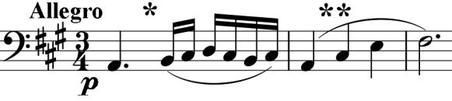

* appears frequently, and its turning semiquavers are extended into longer runs. The

movement ends with the figure puffed into the air by the violin, like thistledown.

The violin opens the *molto espressivo* second movement with a gloriously simple tune, slowly descending by thirds to match the ascending thirds of the first movement's second bar (**). The piano accompanies with the movement's *idée fixe,* a dotted semiquaver pattern (illustrated) which continues almost continuously

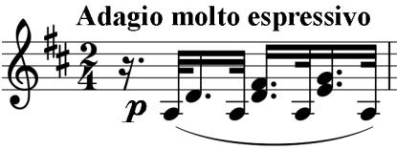

either in the piano or in the violin for the first and last of the movement's three main sections.

The last movement's theme starts with a modification of the rising-thirds figure (**). Its six variations show the ability that made the young Beethoven so lauded as an improvisor on the keyboard. The last variation breaks into a faster 6/8 tempo but still maintains the genial self-confidence of a composer who is happy with the voice that he has found in a medium that had been so dominated by his predecessor, Mozart.