**Ludwig van Beethoven (1770-1827) Piano Trio in G, Op 1 No 2 (1793/5)**

*Adagio - Allegro vivace*

*Largo con espressione*

*Scherzo & Trio: Allegro*

*Finale: Presto*

Beethoven's three Op.1 trios are dedicated to Prince Karl von Lichnowsky who had been generous to Beethoven after his arrival in Vienna. A composer and collector of Bach manuscripts, Lichnowsky had also been very generous to Mozart lending him a substantial sum of money, which Mozart was unable to repay. It has recently come to light that the Prince sued Mozart and, a few weeks before Mozart died, the court found in the Prince's favour and requisitioned half of Mozart's salary from the Imperial Court. Beethoven initially fared better and secured a substantial annuity from the Prince which was paid until the two had a furious quarrel in 1806 causing Beethoven, in turn, to sue Lichnowsky.

Before the three Opus 1 piano trios were published by Artaria in 1795, Beethoven had already written at least 3 piano quartets, 2 other piano trios and a wind octet. He probably began work on his Opus 1 trios in his home town of Bonn, but continued to work on them after his move to Vienna in 1792, where Haydn heard them performed the following year. Haydn advised Beethoven not to publish the C minor trio – the third of the set. Beethoven took offence, thinking Haydn jealous and ill-disposed to him, though Haydn said he was simply trying to protect Beethoven from what he thought would be a hostile public response. Nonetheless, Beethoven delayed publication and revised the trios, partly as a result of Haydn's remarks, but also to ensure good sales on the basis of his growing reputation. His efforts and guile were well rewarded with an initial subscription of 241 copies bringing in the equivalent of many thousand pounds today. The extended family of Prince Lichnowsky, the Trios' dedicatee, bought 52 copies. Not bad for an Opus 1.

The Trios are rich in ideas (' *When I re -read the manuscripts I wondered at my folly in collecting into a single work materials enough for twenty*') and have many of Beethoven'scharacteristic trade-marks. In Beethoven’s hands the piano trio form moves beyond the traditional three-movement design of Haydn and Mozart: he adds a movement, casts the individual movements on a larger scale, and, partly because of improvements in piano technology, is able to free the cello from merely enriching the piano's bass-line. This, the second of the three Op.1 Trios, is the most amiable and serene yet still gives us a large helping of undoubtedly Beethoven surprises, and clear evidence of its composer's genius, especially in its wonderful slow movement.

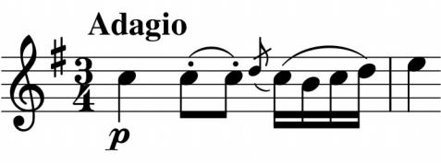

In the work's *Adagio* introduction, while the piano shows off Beethoven's improvisatory skills, the violin presents a motif opening with repeated Cs (illustrated) that will become the *Allegro's* main theme. The *Allegro* itself is extraordinarily rich in ideas with countless unexpected views of the movement's material.

The *Largo* second movement is the emotional heart of the work and an undoubted masterpiece. Its variations are based on two contrasting ideas. The first (illustrated) is one of those sublime, apparently endless themes that appear in many of Beethoven's later works. The second

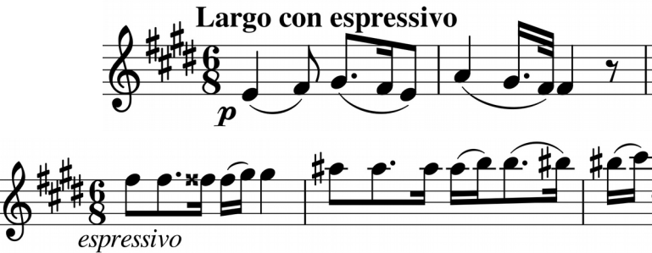

(illustrated) is unsettled, striving upwards in poignant semitones again from a repeated note opening.

The *Scherzo* starts with a faster variant of the opening of the *Largo* and the four repeated notes at the beginning of the *Trio* are linked to those of the work's opening *Adagio* and of the *Largo's* second theme. A witty coda leads us into the whirlwind of the *Finale*. More repeated notes start the movement off – this time ten *Presto* semiquavers on the violin. The cello also gets to play them, but not the piano who has to make do with alternating notes. It would be at least 10 years before Erard's double escapement action allowed pianists the rapid repetition of a note that Beethoven might have enjoyed showing off here.