**Programme notes by Chris Darwin. Use freely for non-commercial purposes**

**Ludwig van Beethoven (1770-1827) Piano Trio in E flat Op 1 No 1 (before 1794)** *Allegro*

*Adagio cantabile*

*Scherzo. Allegro assai*

*Finale. Presto*

Beethoven's three Op 1 trios are dedicated to Prince Karl von Lichnowsky who had been generous to Beethoven after his arrival in Vienna. A composer and collector of Bach manuscripts, Lichnowsky had also been very generous to Mozart lending him a substantial sum of money, which Mozart was unable to repay. It has recently come to light that the Prince sued Mozart and, a few weeks before Mozart died, the court found in the Prince's favour and requisitioned half of Mozart's salary from the Imperial Court. Beethoven initially fared better and secured a substantial annuity from the Prince which was paid until the two had a furious quarrel in 1806 causing Beethoven, in turn, to sue Lichnowsky.

Before the three Op 1 piano trios were published by Artaria in 1795, Beethoven had already written a substantial amount of chamber music: at least 3 piano quartets (WoO

36) , another piano trio (WoO 38) and a wind octet (Op 103). He probably began work on his Opus 1 trios in his home town of Bonn, but continued to work on them after his move to Vienna in 1792, where Haydn, who was teaching Beethoven, heard them performed.

Haydn advised Beethoven not to publish the C minor trio – the third of the set. Beethoven took offence, thinking Haydn jealous and ill-disposed to him, though Haydn said he was simply trying to protect Beethoven from what he thought would be a hostile public response. Nonetheless, Beethoven delayed publication and revised the trios, partly as a result of Haydn's remarks, but also to ensure good sales on the basis of his growing reputation. His efforts and guile were well rewarded with an initial subscription of 241 copies bringing in the equivalent of many thousand pounds today. The extended family of Prince Lichnowsky, the Trios' dedicatee, bought 52 copies. Not bad for the Op 1 of a 25-year-old.

The Trios are rich in ideas ('When I re -read the manuscripts I wondered at my folly in collecting into a single work materials enough for twenty') and have many of Beethoven's characteristic trade-marks. In Beethoven’s hands the piano trio form moves beyond the traditional three-movement design of Haydn and Mozart: he adds a movement, casts the individual movements on a larger scale, and, partly because of improvements in piano technology, is able to free the cello from merely enriching the piano's bass-line.

Perhaps to emphasise these innovations, Op 1 no 1 opens with a backward look to the Mannheim of fifty years earlier. The attention-grabbing rising arpeggio is an example of the Mannheim Rocket – one of a clutch of devices exploited by those composing for the technically brilliant Mannheim orchestra; others included the Roller (a long crescendo), the Tremble and the Sigh. The violin gets to state the second theme (*illustrated*) whose opening (under x) is reused in the

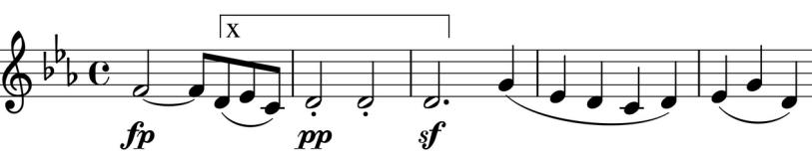

second movement. Towards the end of this genial and boisterous first movement Beethoven plays the false-ending trick – one that

Haydn loved – before a long and novel final coda. The *Adagio* slow movement is, unusually in a rondo

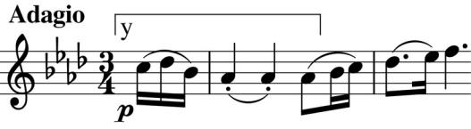

form with the opening material (illustrated) alternating with new ideas. Its start (under y) has an obvious relationship to the x passage of the first movement.

After the *Scherzo* we arrive at the boisterous *Presto Finale* which opens with a provocatively playfully jump of a tenth. More provocations follow – a slithery semitone descent, perhaps cocking a snook at Mozart's chromaticisms, leading into a parody of Haydn's Gypsy Rondo style.

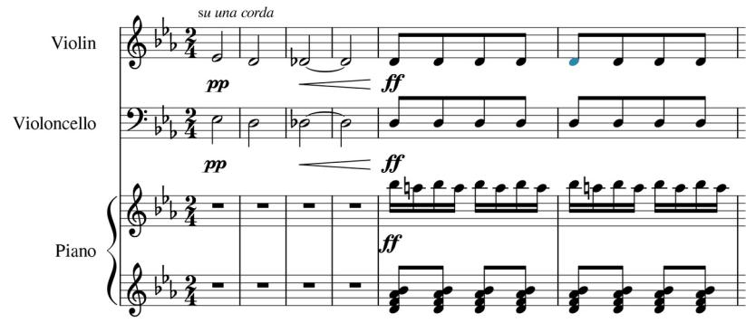

But the best is yet to come. After some daring modulations, the strings try to tip-toe away in a slow pianissimo semitone descent, but the piano leaps out at them blowing a giant raspberry (illustrated) and then skips away as if nothing had happened.