Programme Note by Chris Darwin: please use freely for non-commercial purposes

**Ludwig van Beethoven (1770-1827) String Quartet Op 18 no 5 in A (1801)**

*Allegro*

*Menuetto & Trio*

*Andante cantabile*

*Allegro*

Beethoven was in his late 20s and living in Vienna when he started to write his six Op 18 string quartets. Uneducated (*“I do everything badly except compose”*), rough-mannered, but with an alluringly intense personality and of undoubted musical genius, he had managed to secure the patronage, both as composer and pianist, of Vienna's cosmopolitan aristocracy. Chamber music was an important part of their diet, and Beethoven composed piano trios (Op 1) and string trios (Op 9), violin sonatas (Op 12) and piano sonatas (Ops 2, 10 & 14) before publishing in the 'serious' medium of the string quartet. As models he had Mozart, who had died in 1792, the year that Beethoven arrived in Vienna from Bonn, and Haydn, from whom Beethoven (*“the Great Mogul”* as Haydn called him) had briefly had composition lessons. Whilst their influence is undeniable, Beethoven succeeds in showing us his own distinctive voice, with tantalising seeds of his later quartet style also apparent.

The A major quartet is something of a homage to Mozart, bearing many similarities with his K.464 ('Drum') quartet in the same key. It had particularly impressed Beethoven, who is reported to have said *“That’s a work! That’s where Mozart said to the world: Behold what I might have done for you if the time were right!”* The two quartets not only have the samemovement structure – Minuet second, Theme and Variations third – but also have more detailed similarities. For example, in their

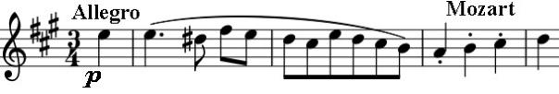

opening bars, both works highlight the same first three notes of the rising A major scale, A, B, C#,

played staccato and piano. Mozart, characteristically, introduces them with a couple of bars of a caressing slowly turning phrase and resolves onto the D. Beethoven, also characteristically, starts with an attention-grabbing chord and a rapid *sforzando* turn, and then leaves

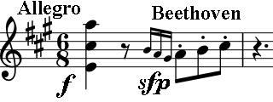

the phrase unresolved, as if to say: “Mozart was great, but I'm different”. Beethoven breaks with tradition in the opening of the Minuet by having the 'repeat' of its first part written out, so that the viola can play its lilting theme instead of the first violin.

As with the Mozart quartet, the heart of this work is the Theme and Variations third movement. Courageously, Beethoven chooses the blandest of themes – little more than a descending scale followed by an ascending scale and then another descent. Following Mozart's lead, Beethoven proves to be his equal as a master of the variation form. Towards the end of the variations, where Mozart introduces the

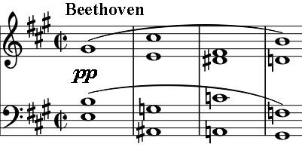

'drum' motif that gives his quartet its epithet, Beethoven unleashes an exuberant outburst, shattering the exquisite calm of the preceding variation. This outburst ends in a wonderfully interrupted cadence introducing two bars of banally drumming cello. The tenderest of episodes leads to a peacefully vanishing ending. The last movement dashes along, its headlong counterpoint interrupted by a slow hymn-like episode (illustrated) echoing a similar passage in the last movement of the Mozart quartet. Mozart gradually winds his last movement down, whereas Beethoven switches to *piano* in just the last two

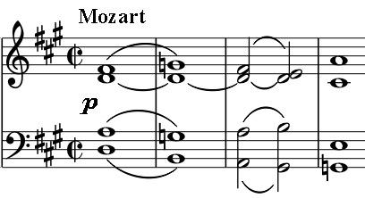

bars. In both cases the music just evaporates.