**Programme notes by Chris Darwin – use freely for non-profit activities**

**Ludwig van Beethoven (1770-1826) String Quartet in D Op.18 No.3** *Allegro*

*Andante con moto*

*Allegro – Minore*

*Presto*

Beethoven was in his late 20s and living in Vienna when he wrote his six Op 18 string quartets. Uneducated (*“I do everything badly except compose”*), rough-mannered, but with an alluringly intense personality and undoubted musical genius, he had managed to secure the patronage, both as composer and pianist, of Vienna's cosmopolitan aristocracy. Chamber music was an important part of their diet, and Beethoven composed piano trios (Op 1) and string trios (Op 9), violin sonatas (Op 12) and piano sonatas (Ops 2, 10 & 14) before publishing in the 'serious' medium of the string quartet. As models he had Mozart, who had died the year that Beethoven arrived in Vienna from Bonn, and Haydn, from whom Beethoven (*“the Great Mogul”* as Haydn called him) had briefly had lessons in composition. Whilst their influence is undeniable, Beethoven in these early chamber works already has his own voice, with tantalising seeds of his later style clearly apparent.

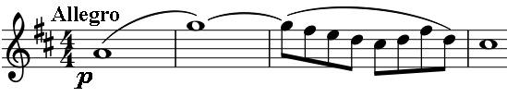

The opening ten-bar phrase of the third of his Op

18 quartets is entirely novel in its gentle stillness:

a rising seventh in semi-breves in the first violin is

followed by a leisurely decorated descent. The viola starts the phrase again, but is interrupted by the second and then the first violin who then extends the decorative quavers into a more rhythmically forceful figure leading us off on a proper *Allegro*. The movement explores the contrast between the stasis of the opening semi-breves and the movement of the decoration. The interval of the seventh recurs both rising and falling, often as the endpoints of the many running quaver and triplet figures that pepper the movement.

The *Andante* is a very succesful combination of a serious opening theme in walking quavers with gracefully jaunty episodes; the Rondo form reveals Beethoven's wonderful ability to vary simple material. The following *Allegro* in triple time, is marked neither *Minuet* nor *Scherzo* although it has the appropriate form. Its *Minore* section in D minor is built on the same descending four note bass line that

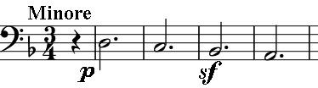

underlies many 17th-century Chaconnes, notably Bach's for solo violin in the same key.

The *Presto* last movement's opening 'Mexican hat-dance' motif is again built on a seventh, this time falling (under [1]). The movement has great vitality and wit. Watch out for the

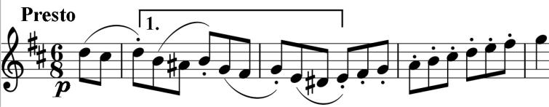

game of musical tennis as the first three notes of the opening are batted between the players, and how they simply evaporate into the silence of the final two bars – a joke that Haydn would have been proud of.