**Programme note by Chris Darwin: use freely for non-commercial purposes**

**Ludwig van Beethoven (1770-1826) String Quartet in F Op 18 No 1 (1799)** *Allegro con brio*

*Adagio affettuoso ed appasionato*

*Scherzo. Allegro molto*

*Allegro*

Beethoven was in his late 20s and living in Vienna when he wrote his six Op 18 string quartets. Uneducated ('I do everything badly except compose'), rough-mannered, but with an alluringly intense personality and undoubted musical genius, he had managed to secure the patronage, both as composer and pianist, of Vienna's cosmopolitan aristocracy. Chamber music was an important part of their diet, and Beethoven composed piano trios (Op 1) and string trios (Op 9), violin sonatas (Op 12) and piano sonatas (Ops 2, 10 & 14) before publishing in the 'serious' medium of the string quartet.

The great success of his three Op 9 string trios, published in 1798, encouraged him to accept a commission from Count Lobkowitz for six quartets. As models he had Mozart, who had died the year that Beethoven arrived in Vienna from Bonn, and Haydn, from whom Beethoven (“the Great Mogul” as Haydn called him) had briefly had lessons in composition. Whilst their influence is undeniable, Beethoven in these 'early' (he was after all 29) chamber works already has his own voice, with tantalising seeds of his later styles clearly apparent. At the same time as commissioning Beethoven, Lobkowitz had also commissioned 6 quartets from Haydn. Perhaps recognising the quality of Beethoven's works, and not wishing to subject himself in Viennese soirées to a direct comparison with his erstwhile pupil, Haydn only wrote two of the requested six quartets (Op 77) and completed no more quartets in his lifetime.

The striking opening phrase of the *Allegro con brio* (illustrated) is a speeded-up version of the opening of an earlier (Op 3) String Trio's *Adagio* (illustrated). Its simple, easily recognisable shape helps the listener follow the upcoming complex contrapuntal writing – perhaps a cunning ploy by Beethoven to help win over his audiences to this revolutionary music.

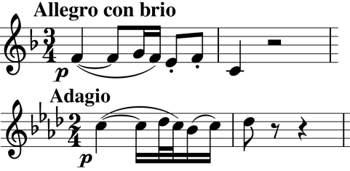

The burial vault scene in Romeo & Juliet is known to have provided the inspiration for the extraordinarily dramatic slow movement. The long melodic line of the opening, and indeed the dramatic model for the movement as a whole, perhaps benefitted from the lessons in vocal composition that Beethoven was having at that time from Salieri. However, no-one but Beethoven could have written this movement. Unprecedented gestures such as the unbearably long silences building to the final climax are pure Beethoven at his most daring.

The Scherzo is no comfort after the death throes of the Adagio, with its odd phrase-lengths and swerving harmonies – especially taxing for the first violin in the Trio.

Beethoven certainly confirms his contrapuntal credentials in the triumphant final Allegro. The tumbling triplets of its opening (illustrated) are again an echo of an earlier String Trio (Op 9 no 3 *Presto*; illustrated), and, like the opening of this quartet's first movement, provide an easily recognisable motif for the listener as Beethoven plies us with fugal flourishes.

