Programme Note by Chris Darwin: please use freely for non-commercial purposes

**Ludwig van Beethoven (1770-1827) String Quartet in F major, Op.135 (1826)**

*Allegretto*

*Vivace*

*Lento assai, cantante e tranquillo — Piú lento — Tempo I*

*Grave, ma non troppo tratto* — *Allegro* — *Grave, ma non troppo tratto — Allegro*

The stimulus for Beethoven to return, after 12 years, to composing string quartets was a commission in November 1822 from Prince Galitzin for “1, 2 or 3 quartets”. Had it not been for the intervention of Karl Zeuner, the viola player in Galitzin's own quartet, the commission would have gone to Weber, whose recent opera *Der Freischütz* Galitzin admired. Beethoven fulfilled the commission in November 1825 with the three increasingly complex quartets Op 127 (4 movements), Op 132 (5 movements) and Op 130 (6 movements ending in the *Grosse Fugue*). He continued to write, finishing the seven-movement C# minor quartet Op 131 in August 1826. He then immediately began work on today's F major quartet Op 135, which is dedicated to his good friend and amateur musician Johann Wolfmayer. Beethoven had intended to dedicate Op 131 to Wolfmayer but at the last minute switched to Baron von Stutterheim in gratitude for his mercifully securing a regimental position for Karl, Beethoven's suicidal nephew and ward.

This F major quartet is altogether different from the long and complex works that preceded it, but no less lacking in creative energy. Its compactness is reminiscent of the intense F minor *Quartetto Serioso* Op 95 which the Castalian played at the beginning of this season. But now, the opening mood is capriciously quirky. The viola's Eeyore-like, opening glumness raises a giggle in the first violin; another grumble from the viola, and a 'you can't be serious' from both violins. The viola then cheers up with a rising figure to the cello's tripping pizzicato and the violins agree that that is the way to go. We are soon introduced to two more ideas: a more solemn thought on a falling crotchet figure in octaves and an altogether happier figure in moving semiquavers.

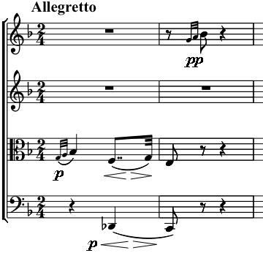

The scherzo opens with complex cross-rhythms between the instruments (where is the downbeat?) as the violin moves in simple steps A-G-F-G-A-G-F, with the cello in contrary motion. An unexpected Eb stops everyone in their tracks. What has happened? Where are we going? False alarm! Just slide up a semitone, and lead back to F as if nothing had happened. The trio section starts innocuously with ascending scales against a simple repeated accompaniment, but the first violin keeps on going high, and ominously having to drop back to earth. The music then turns into a forerunner of the Rite of Spring. The first violin goes mad, fortissimo, with wild leaps, while the other instruments beat out a threateningly insistent pianissimo rhythm. The keys abruptly change from F to G to A – the steps of the initial scherzo theme. The leaps eventually run out of energy, and we are expertly led back to the relatively reassuring world of the scherzo.

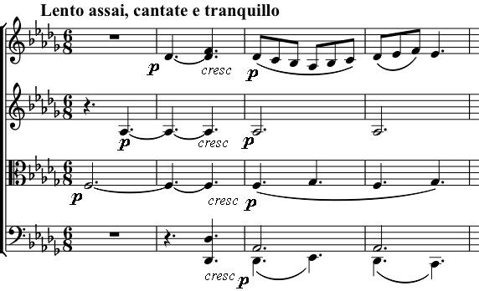

The viola starts the slow movement on a simple *piano* F, the tonic of our home key. But as the other instruments build up a soft, warm chord, the F turns out to be the third of the remote key of Db. What follows is, even in the context of the late quartets, one of Beethoven's most heartfelt

movements. The serene, hymn-like melody is made up of simple steps, like the opening of the scherzo, but transports us into an altogether different world. After twenty or so bars, the music undergoes an abrupt change in tempo, mood and key. Painfully slow, enervated, this first variation, in C# minor, is as despairing as anything in Shostakovich. The mood, thankfully, lifts as the third variation returns to the original key and tempo. In the last variation, a reassuring lullaby, the first violin quietly comments on the theme over a gently rocking accompaniment.

The last movement has the following portentous heading:

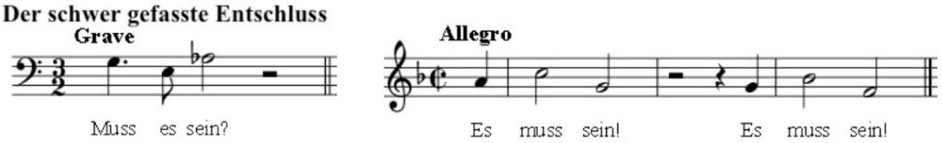

[ The hard-to-make decision. “Must it be?” “It must be!” ]

Although this heading can easily be endowed with much existential significance, its origins, at least, are financial (as Michael Steinberg points out in *“The Beethoven Quartet Companion”*). It was the habitual dialogue between Beethoven (bass clef) and 'Frau Schnapps' (treble clef) when she requested her housekeeping money. It later arose in a conversation between two of Beethoven's acquaintances Holta and Dembscher. Beethoven would not provide Dembscher with the parts to his quartet Op 130 because Dembscher had not paid the subscription to attend its recent performance by the Schuppanzigh quartet. Holta suggested that Dembscher pay Schuppanzigh the subscription fee whereupon Dembscher asked “Muss es Sein?” Beethoven was amused and wrote a brief, comic 4-part canon to the words “Es muss sein! Ja, ja, ja. Heraus mit dem beutel” [It must be! Yes. Out with your purse!]. This canon provides the *Allegro* theme illustrated above and its inversion the preceding *Grave*. Beethoven later wrote to his publisher: *“You see what an unhappy man I am, not only that [this quartet] was difficult to write because I was thinking of something else much bigger, but because I had promised it to you and needed the money; and that it came hard you can gather from the 'it must be'.”* So perhaps, “it must be the last movement, since I need the money”.