**Programme notes by Chris Darwin – Use freely for non-commercial purposes**

**Ludwig van Beethoven (1770 - 1827) String Quartet in A minor, Op.132 (1825)**

*Assai sostenuto – Allegro*

*Allegro ma non troppo*

*Molto adagio*

*Alla marcia, assai vivace – piú allegro*

*Finale (allegro appassionato)*

Beethoven’s last three years (1824-7) were predominantly occupied in composing what we now refer to as his late string quartets: Ops 127, 132, 130 (with its original ending the Great Fugue Op 133 ), 131 and 135. In November 1822, it had been 12 years since he had completed a quartet - the F minor Op 95 Serioso - and his interest in quartet writing might never have seriously revived had he not had a commission for “one, two or three quartets” from Prince Nicholas Galitzin, an excellent young amateur cellist from St Petersburg, living in Vienna. It is said that the commission almost went to Weber, whose recent opera Die Freischütz, had excited Galitzin; but fortunately Karl Zeuner, the viola player in Galitzin’s own quartet, nudged him towards Beethoven instead. Completing the Missa Solemnis and the Ninth Symphony occupied Beethoven for another eighteen months, but he finished three quartets for Galitzin, Ops 127, 132 and 130, in February, July and November of 1825. Op 131 followed, uncommissioned, immediately after.

The germinal idea of Op 132 is a pair of semitones (G#-A, E-F) in the cello's opening phrase (illustrated), which is joined by the other three instruments playing variants of the same motif. This

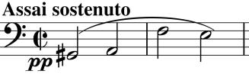

slow introduction is broken by rapid semiquavers from the first violin leading into an important motif (illustrated) which starts with one of the opening's semitone pairs (E-F). The dotted rhythm (under y) provides a

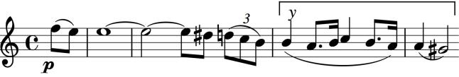

rhythmic engine to the movement and ends with the other semitone pair (G#-A).

The lilting opening of the following movement – a sort of Minuet and Trio - is again rich in pairs of semitones. Its mixture of the gentle and the acid always surprises, as does the curious Trio section with its bagpipe-like drone, its tricky part for the viola and the violent buffeting of a section in duple rather than triple time.

Beethoven had become worryingly ill with stomach problems in April 1825. His doctor strictly implored him (he admired Beethoven's music) to forgo wine, coffee and all spices. Beethoven obeyed, the change in diet worked and a few weeks later Beethoven was back to composing. The gratefully heartfelt

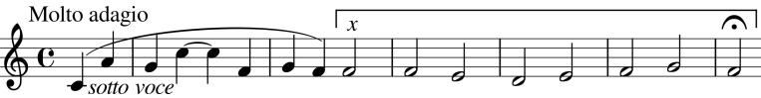

slow movement is entitled "A Hymn of Thanksgiving from a Convalescent to

God, in the prayerful Lydian mode". Like a Bach chorale prelude, the movement opens (illustrated) with the lines of a hymn (under *x*) interleaved by faster moving phrases. After the hymn, there is a dramatic change to the optimism of D major for a faster variation section marked "New Strength" in which the two violins dance around each other. The hymn, with its interleaving phrases now more syncopated, returns followed again by a variation and finally by a yet more syncopated fantasia on the hymn marked "with the most intimate feeling". The convalescent falls asleep with gentle sighs...

...only to woken by a disturbing March, with stresses on the wrong beats and a sinister fading of the motif in the second bar. This March is very soon interrupted by a recitative

from the first violin. It is similar in form to the cello/bass recitatives in the Ninth Symphony, but here the mood is anguished, terrified, culminating in what Joseph Kerman describes as a scream as the violin holds a high F and then cascades down to a desolate bar of the semitone E-F that leads into the final movement.

The E-F semitone forms the second violin's neurotic accompaniment (illustrated, under *x)*, to the first violin's restless theme with its G#-A semitone (under *y*). A gentler theme with decorative trills brings some hope, but wild cross-rhythms augment the tension

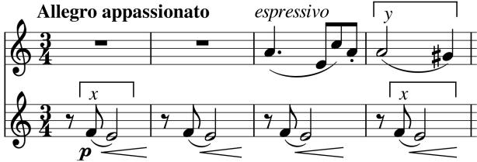

culminating in an anguished outburst high on the cello as the tempo hits Presto. But the key then shifts to a radiant A major, and the quartet ends in a mood of joyful optimism.

Angus Watson's "Beethoven's Chamber Music in Context" was helpful in preparing these notes.