Programme notes by Chris Darwin. Please use freely for non-profit activities

**Ludwig van Beethoven (1770-1827) String Quartet in C# minor Op. 131 (1826)** *Adagio ma non troppo e molto espressivo*

*Allegro molto vivace*

*Allegro moderato – Adagio*

*Andante ma non troppo e molto cantabile – Più mosso – Andante moderato e lusinghiero*

*– Adagio – Allegretto – Adagio, ma non troppo e semplice – Allegretto Presto*

*Adagio quasi un poco andante Allegro*

Beethoven completed the three string quartets commissioned by Prince Galitzin (Op 127, 130 & 132) in 1826 after his Ninth Symphony. According to Karl Holz, the second violin in Ignaz Schuppanzigh's string quartet, who had effectively become Beethoven's secretary: *'While composing the three quartets... such a wealth of new quartet ideas flowed from Beethoven's inexhaustible imagination that he virtually had to write the Quartets in C-sharp minor and F major involuntarily. "My dear fellow, I've just had another idea," he would say jocularly and with glistening eyes when we were out walking, and would write down a few notes in his sketchbook.'*

The C-sharp minor quartet is extraordinary in many ways. It is unique among Beethoven's works in having seven continuous movements (continuing the increasing complexity from Op 132 to Op 130) and in starting with a fugue. Beethoven had recently finished writing the wildest of all fugues, the *Grosse Fugue* last movement of Op 130; by contrast, the opening of Op 131 is serene; *'It is as though Beethoven were rendering a peace offering to the fugue gods'* (Michael Steinberg).

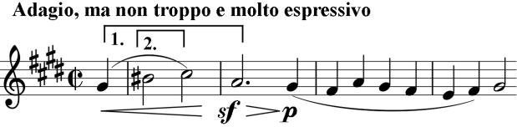

As in his two previous quartets, Beethoven builds Op 131 around two pairs of semitones: initially a G#-A [1] B#-C# [2] sandwich for the opening four notes of the fugue. The fugal line

becomes more complex with syncopations and more rapid movement. Shortly before the end, the cello enters with the main theme at half the original speed against the first violin at normal speed. The movement ends on a simple C#-

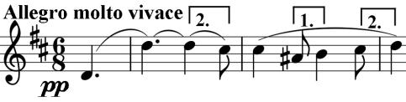

octave jump. Then comes the Beethoven trick of simply sliding up a semitone, to a D-octave jump, and, Hey *Allegro molto vivace*, we are in the *Scherzo* second movement with a new arrangement of two semitones:

A#-B [1] and C#-D [2]. After an almost petulant *fortissimo* outburst, the music subsides to well-separated *pianissimo* chords that are not quite

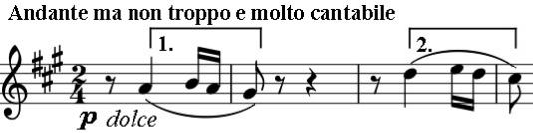

final, and we go straight into a short bridging recitative heralding the fourth movement - a set of extraordinary variations that form the heart of the whole work.

Again the theme starts with two pairs of semitones: A-

G# [1] and D-C# [2]. The silent or deemphasised first beat is an important part of the theme. Listening to these variations it is easy to see why Beethoven the young pianist was so lionised for his ability to improvise, and why he himself wrote of this, his greatest quartet, that it showed *'less lack of imagination than before'*. There is another tentative ending and then, like a Shakespearean jester, the cello bursts in with the whirlwind *Presto:* a *Scherzo* packed with wit and contrast. After a couple of cycles of *Scherzo-Trio* the music seems to get lost and the players scurry around scratching a thin *sul ponticello* before

Beethoven brings them to heel, abruptly stops the movement and immediately switches key, tempo and mood, leading us briefly into a world as serene as that of the opening fugue.

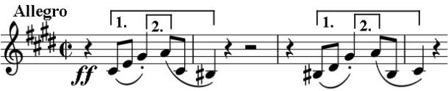

But we are brusquely kicked out of this world into the stormy, harsh intensity of the finale. Again semitones shape the opening theme: B#-

C# [1] and G#-A [2]. We are now back in the 'home' key of C# minor for almost the first time since the first movement, and Beethoven establishes other links with the first movement to give a sense of closure. The climax comes with triumphantly majestic long descending octaves in the first violin, but the movement does not end easily: there are violent swings of mood and tempo before Beethoven swerves into C#-major for the final six bars of this huge work.

Coda: Five days before Schubert's death in November 1828, Op 131 was played at his bedside. Karl Holz who was present wrote: *"The King of Harmony has sent the King of Song a friendly bidding to the crossing."*