Programme Note by Chris Darwin: please use freely for non-commercial purposes

**Ludwig van Beethoven (1770-1827) String Quartet in E**♭ **Op. 127 (1825)** *Maestoso – Allegro*

*Adagio, ma non troppo e molto cantabile – Andante con moto Scherzando vivace*

*Finale. Allegro*

Beethoven’s last three years (1824-7) were predominantly occupied in composing what we now refer to as his late string quartets: Ops 127, 132, 130, 131 and 135. In November 1822, it had been 12 years since he had completed a quartet - the F minor Op 95 *Serioso.* He had made sketches for another quartet and indeed in the summer of 1822 the publishers Peters turned down an offer of a string quartet, but his interest in quartet writing might never have seriously revived had he not had a commission for “one, two or three quartets” from Prince Nicholas Galitzin, an excellent young amateur cellist from St Petersburg. The commission almost went to Weber, whose recent opera *Die Freischütz*, had excited Galitzin; but fortunately Karl Zeuner, the viola player in Galitzin’s own quartet, nudged him towards Beethoven instead. Ignaz Schuppanzigh, the leader of Beethoven's preferred quartet, was visiting St Petersburg around that time and might also have contributed to Beethoven getting the commission. Completing the *Missa Solemnis* and the Ninth Symphony occupied Beethoven for another eighteen months, but he finished three quartets for Galitzin, Ops 127, 132 and 130, in February, July and November of 1825.

The Op 127 quartet reflects Beethoven's more genial and productive state of mind following the difficult years of the mid-1810s. Like the *Hammerklavier* sonata of 1818 it carves out radically new musical paths. The first performance by Schuppanzigh's quartet in 1825 was a failure and another a few weeks later with a different leader fared little better. It was only after players and audience alike had grown more accustomed to the music that it was appreciated by more than a small group of enthusiasts and Beethoven felt he could report to his publisher Schott's that "*People have a high opinion of the quartet. It is supposed to be the greatest and most beautiful quartet I've written, so they say...*".

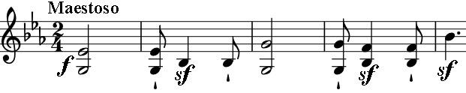

The key of E-flat major for Beethoven is associated with grand gestures, and the opening of this quartet recalls the

opening of the *Eroica* Symphony and the *Emperor* Concerto. We are in a serious and mysterious world. But after a mere six bars *Maestoso* gives way to *Allegro, piano e dolce, teneramente* (tenderly) *-* early sketches were even headed *"la gaieté",* perhaps in contrastto *"La Malinconia"* (melancholy) in the last of the Op 18 quartets*.* However, the *Maestoso* opening and its two reappearances warn us not to be deceived into thinking that this is an altogether light-hearted quartet.

Its depth is clear in the extensive slow movement: a set of six wonderful variations. The

slowly syncopated, pulsing cello starts the build-up of a dominant seventh chord from

which the first violin sings the long theme. The first variation disturbs the serenity of the

theme with a faster tempo and increased syncopation. Then the music speeds up again to

*Andante con moto* and the two violins gambol above a persistent staccato accompaniment

from the viola and cello. The gambolling eventually fades and the fourth variation

dramatically shifts key from 4-flats to 4-sharps via a favourite Beethoven trick of simply

sliding up a semitone (*) from C to

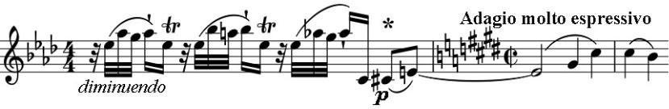

C#, as if he needs to be in E major

so he just goes there by the shortest route. The tempo changes too, to a slow two-beat *Adagio molto espressivo,* for a variation of the utmost serenity. At the end of the variation, the lower instruments pulse the new time, and the first violin returns us to 4-flats as we left it, with a (now downwards) semitone shift. The first violin and cello share an ecstatic duet, alternating the theme with accompanying arpeggios and trills. The final variation consists of a stream of semiquavers, initially in the first violin, but then enriched in the three lower parts. The music suddenly stops for a full half bar, pulsing quavers start and the first violin leads us to the end of our visit to a new and strange world.

The *Scherzo's* complex rhythms contrast with its hurtlingly fast trio. Again Beethoven plays with halting the music abruptly, fooling us into thinking that we are in for a second dose of trio, before abruptly calling a halt. For most of the Finale, we are entertained by genial and at times rustic music, but towards the end, the metre changes, and the main theme undergoes an unearthly transformation against rapid triplet semiquavers. Beethoven opens a door back to the serious and mysterious world of the slow movement, where he leaves us.