**Programme notes by Chris Darwin – please use freely for non-profit activities**

**Ludwig van Beethoven (1770-1827) Sonata in D for cello & piano Op 102 No 2 (1815)** Allegro con brio

Adagio con molto sentimento d'affetto

Allegro

Beethoven's five cello sonatas cover all three of his major creative periods: the first two (Op 5) were written when he was a young piano virtuoso of 25, the third Op 69 is from his 'middle' period while the two Op 102 cello sonatas, together with the contemporary Op 101 piano sonata, mark the start of Beethoven's 'late' period. They come at the end of a frustratingly unproductive time for a man beset by both personal and political problems: deteriorating health, a troublesome nephew and the cultural brutality of Metternich's Austria. The Op 102 cello sonatas are dedicated to Beethoven's stalwart friend the amateur pianist Countess Marie Erdödy, on whose estate Joseph Linke was living. Linke had been the cellist in Count Razumovsky's string quartet, led by Ignaz Schuppanzigh, and he probably gave the first performance of the new sonatas in the summer of 1815 with the Countess on piano.

The new 'late' style of these sonatas can be terse – they are half the length of the Op 5s – drawing extensively on Baroque devices such as counterpoint and fugue. For Beethoven, these devices are not mere rehashes of Bach and Handel; they need, using his word, to be something more 'poetic'. Another feature of the new style appears in this sonata: extreme contrast between the busily energetic outer movements and an exquisitely expansive slow movement.

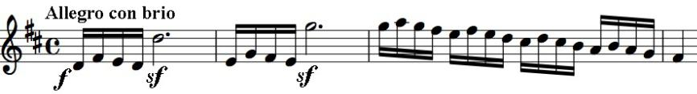

The flourish of the opening bar grabs your attention before you are bundled down

the staircase of descending semiquavers and embraced by the soulful cello. The movement swings unpredictably between extreme moods – anger, tentative wistfulness. There are brief moments of tender beauty, but you are never allowed to bask in them - they are whisked away.

The slow movement by contrast almost suspends time. It opens with a dirge-like chorale,

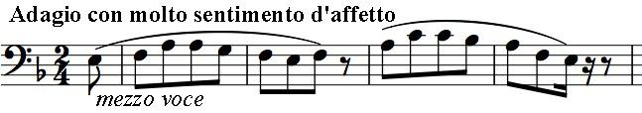

whose individual phrases have

disturbingly abrupt final notes. An

answering phrase introduces the

sinister dotted rhythm which will

insistently dominate the movement.

The cello introduces the last movement with a simple rising scale, as if asking permission to use it. The piano echoes it affirmatively, and the cello starts the fugue, whose wild 'poetic' intensity baffled contemporary audiences. This sonata has much in common with the Op 130 string quartet written ten years later, whose final Great Fugue is even wilder and more baffling.