**Programme notes by Chris Darwin. Use freely for non-commercial purposes**

**Ludwig van Beethoven (1770-1827) Beethoven Horn Sonata Op 17 (1800)** *Allegro moderato*

*Poco adagio, quasi andante*

*Rondo - Allegro moderato*

In 1746, the dedicatee of this work was born Jan Václav Stich, the son of a Bohemian serf bonded to Count von Thun of Žehušice. Thun generously ensured an excellent musical education for the boy: singing, violin, and finally horn. He was sent to study horn in Prague, Munich and Dresden where he learned the hand-stopping technique (to extend the number of notes the natural horn could play), which he was later to improve and develop. Aged 16 he returned to Thun's estate but after four years fled. Thun, incensed by his investment's ingratitude, sent a posse after him with instructions to knock out his two front teeth so he would never play the horn again. Fortunately, the posse failed to catch him; Stitch crossed into Italy and changed his name into its rough Italian translation Giovanni Punto.

Punto become the foremost horn player in Europe, travelling widely. He met Beethoven in Vienna in 1800 and inspired this sonata which was premiered by the two of them that April. It is said that Beethoven wrote out the horn part the night before the concert, and largely improvised the piano part. To expand his sales,

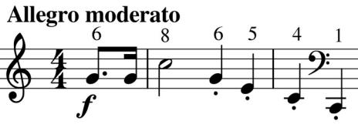

Beethoven arranged the sonata for cello, and it was subsequently also arranged by the Bohemian oboist Carl Khym for string quintet.

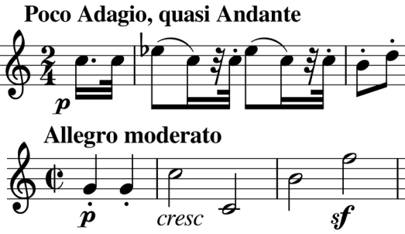

The arresting opening on the horn is built on the unmodified harmonic notes of the natural horn in F (illustrated: the numbers are the harmonic numbers of the notes). Its dotted rhythm opens the short second movement (illustrated) which leads directly into the last whose opening (illustrated) also shares aspects of the initial phrase.