**Programme note by Chris Darwin. Use freely for non-commercial purposes Ludwig van Beethoven (1770-1827) ‘Bei**

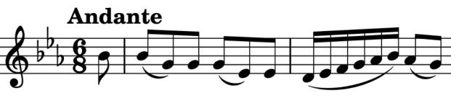

**Männern’ Variations for cello & piano WoO 46 (1801)**

These seven variations, on Pamina and Papageno's famous duet "Bei Männern, welche Liebe fühlen" (*illustrated*) from Act I of Mozart's Magic Flute, were written a few years before the *Appassionata*. They are dedicated to Count Johann Georg von Browne, a general in the Russian army then living in Vienna. He subscribed to Beethoven's Op 1 piano trios and, must have been highly regarded by the composer who described him as the ‘first Maecenas of his Muse’. He and his wife were also the dedicatees of the Op 9 string trios and the Op 10 and the three Op 22 piano sonatas. But according to an employee he was not without failings: "one of the strangest of men, full of excellent talents and beautiful qualities of heart and spirit on the one hand but, on the other, full of weakness and depravity". The variations reflect none of the General's alleged failings, nor indeed the extremes of the future *Appassionata*. But they do bring out many of the beautiful qualities of the cello.