**Programme note by Chris Darwin. Use freely for non-commercial purposes**

**Ludwig van Beethoven (1770-1827) Piano Sonata in F minor Op. 57 '*Appassionata*’ (1804-6)**

*Allegro assai*

*Andante con moto*

*Allegro ma non troppo - Presto*

The *Appassionata* sonata is one of many masterpieces that Beethoven wrote in the early 1800s, along with the *Waldstein* sonata, the *Eroica*, 4th, 5th and 6 th symphonies, *Fidelio*, the *Razumovsky* Op 59 Quartets and the *Kreutzer* violin sonata, amongst others. The powerful emotions expressed in the music emanate from a turbulent time for Beethoven: increasing deafness, emotional attachment to Josephine von Brunsvik and disillusion with his erstwhile hero Napoleon.

But, more prosaically, the *Waldstein* and *Appassionata* sonatas also reflect the fact that Beethoven in 1803 had a new piano – an Erard with a more powerful sound and an extended upward compass. Grove's Dictionary notes: "the *Appassionata* Sonata is ... a work of the greatest extremes – as witness the fortissimo chord handfuls that shatter the brooding quiet of the very first page. This and other equally violent effects were hardly thinkable on the Walter fortepiano owned by Beethoven before 1803."

Not only dynamic extremes but also a relentless rhythmic vigour drive this movement. Beethoven's early sketches of the first movement were in common time (4/4: 4 crotchets to the bar), rather than the more complex

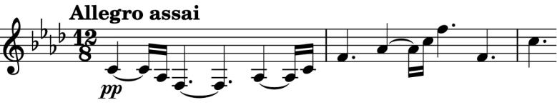

12/8 (4 dotted crotchets to the bar). Denis Matthews' BBC Music Guide points out the rhythmic implications of this change. First, in the opening

beat's long plus short notes (*illustrated*) Beethoven opts for the crisp, but notationally complex tied semiquaver plus semiquaver rather than the more straightforward but more sluggish crotchet plus quaver. The ensuing spiky rhythm is pervasive and drives the movement. The second rhythmic feature is the recurring,

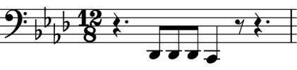

sinister triplet figure in the base (which sits naturally in 12/8) (*illustrated*).

The theme of the second movement's variations could scarcely be melodically simpler: two repeated 4-bar phrases each having only two different pitches. The base line though is rhythmically interesting with a crisp double dot contrasting with more sluggish singles. The variations become rhythmically faster, each doubling in the speed of the accompanying figures before collapsing into the return of the initial theme. The link to the finale is justly famous: two consecutive diminished seventh chords, the first *pianissimo*, the second an octave higher and *fortissimo*, and we are off on stormy seas, fast but *non troppo* so that there are enough revs left for the final *Presto* to work its cathartic magic.