**Programme notes by Chris Darwin. Use freely for non-commercial purposes**

**Amy Beach (1867-1944) Piano Quintet in F# minor Op.67 (1907)**

*Adagio - Allegro moderato*

*Adagio espressivo*

*Allegro agitato - Adagio come prima - Presto*

Amy Beach (or Mrs. H.H.A. Beach as she appears on the score) was a musical prodigy who, against cultural norms, became one of the leading American composers of the early 20th century. She was the only child of the Cheneys – an affluent liberal and musical family in Maine. Aged four she composed four waltzes for piano in her head while staying at her grandfather's piano-less farm. Her mother taught her piano from age 6 and a year later she gave her first public recital including some of her own compositions. On moving to Boston the family resisted advice to send the 8-year old Amy to a European conservatory; instead her progress with local teachers was monitored by a group that included Henry Longfellow, Oliver Wendell Holmes and a physician called Henry Beach whom she married aged 18 although he was 24 years her senior.

Prior to her marriage she very successfully performed numerous concertos with local orchestras including the Boston Symphony. However, Dr. Beech insisted that after her marriage she should give only one or two recitals a year. Her abundant musical energy was then, fortunately for us, diverted to composition. She spent 10 years independently studying the masters which resulted in the composition of a very substantial and varied body of work including many distinguished commissions. This particular period ended with her husband's death in 1910, and her move to Europe to develop her performing career.

Perhaps the seed for today's Piano Quintet was sown by Beach performing the Brahms Piano Quintet with the Kneisel Quartet in 1900. Beach's Quintet has a Brahmsian flavour "from the jagged chromatic melody and contrasting lyrical passages, irregular phrase lengths, its key changes and lush texture, to its strict adherence to the sonata-allegro form."

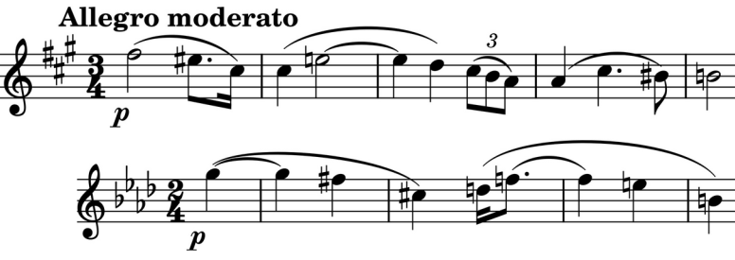

The work opens with mysterious

arpeggios on the piano against a held

F# on eerily thin strings, followed by a

mournfully descending line. The main

*Allegro moderato*'s theme (*illustrated*) is said

to be derived from the second subject in the

last movement of the Brahms Quintet

(*illustrated*). This theme recurs in various

forms throughout the work. Gentle F# octaves in the piano introduce the more optimistic *cantabile* second theme

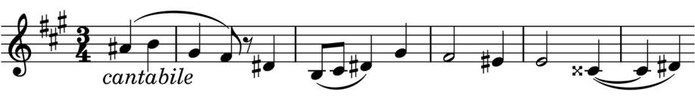

(*illustrated*); these two main ideas are beautifully contrasted and developed.

If Amy Beach had written nothing more than the following slow movement she would have won her place among my romantic

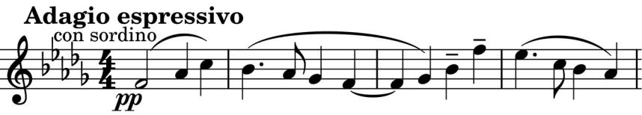

greats. It opens with a gorgeously serene melody on muted strings (*illustrated*) taken up by the piano and then ingeniously inverted by

the viola and cello, showing its relationship to the opening *Allegro* theme, which fuels occasional darker intrusions into the prevailing serenity.

The last movement kicks us awake

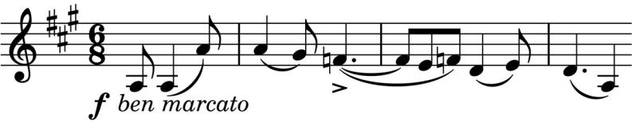

with a restless motif which soon

emerges full blown in the strings

(*illustrated*). Its agitation gives way

to quiet reflection led by the viola.

Violin and piano above tremolo strings have a recitative-like exploration recalling the mood of the work's opening. Their conversation is ended by the cello starting a fugue with repeated semiquavers on the *marcato* theme, which rapidly builds to a powerful climax. The work's mysterious introduction returns. An altogether more optimistic mood now carries us to a buoyant P*resto* and a final acknowledgment of the Brahms theme played, as in the closing moments of the original, by unison strings.