**Programme notes by Chris Darwin – use freely for non-profit activities**

**Béla Bartók (1881-1945) String Quartet No 4 (1928)**

*Allegro*

*Prestissimo, con sordino*

*Non troppo lento*

*Allegretto pizzicato*

*Allegro molto*

Bartók's third and fourth quartets were written within a year of each other, fully ten years after his second quartet. In July 1927 Bartók heard Alban Berg's *Lyric Suite* for string quartet at a concert in Germany. According to Stephen Walsh in his BBC guide to *Bartók's Chamber Music,* this was the likely stimulus for Bartók returning to quartet writing. Berg had incorporated Schoenberg's atonality into a wide range of techniques, producing extreme contrasts of mood, texture and tempo, whilst still aiming for the traditional virtue of beauty of sound. Bartók married Berg's eclectic approach to his own enthusiasm for Hungarian folk-music, with its powerful rhythms and harsh, dissonant sounds. He did this within that most refined and intellectual of musical forms – the string quartet. Not surprisingly, Berg is said to have found the harsh energy of Bartók's fourth quartet 'too cacophonous'. Bartók's third and fourth quartets are a richly complex, exciting and sometimes bewildering marriage of the composer's passionate appreciation of Hungarian folk-music with the intellectual rigour of classical musical forms and of recent atonal innovations.

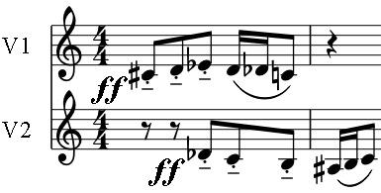

For example, a significant theme in the first and last movement of tonight's fourth quartet is a violent 6-note arch-shaped motif which first occurs near the beginning. The motif moves in semitones – one of the characteristic intervals of Hungarian folk-music. But notice also that the original motif in the first violin is immediately echoed by an inverted version in the

second violin, to produce a dissonant series of seconds with the original.

A major structural feature of Bartók's Fourth Quartet, and one that it shares with those of Haydn's Op1, is that the five movements form an arch-like structure ABCBA, with the middle, slow movement the heart of the work. Bartók described the quartet as follows:

*'The slow movement is the nucleus of the piece, the other movements are, as it were, bedded around it: the fourth movement is a free variation of the second one, and the first and fifth movements are of the identical thematic material. Metaphorically speaking, the third movement is the kernel, movements I and V the outer shell and II and IV, as it were, the inner shell.'*

Although the fourth movement is a 'free variation of the second one', the two movements have very different sounds. The second is extremely fast and muted, like fluttering moths but with a variety of strange sounds – slithering semitones, slides and strums; the fourth is from a land of darting invertebrates, punctuated by the 'Bartók pizzicato' where the string is pulled so that its release slaps the fingerboard.

Between all this restlessness, the third movement is a very different world – the stillness of Bartók's 'night music'. The upper strings hold long chords against the cello's initial plaintive melody. The slowly-changing chords become more dissonant, the melody more decorated and the tempo more agitated before settling back down again. The chords do not traditionally harmonise the melody,

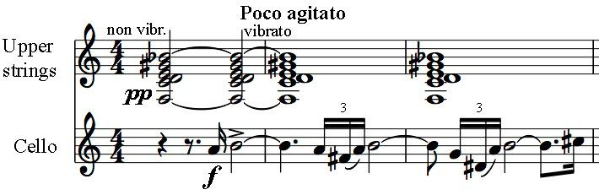

rather they supply notes that the melody lacks. For example, after about 20 bars the held chord has 6 of the notes of the chromatic scale, the cello melody the other six - a striking example of Bartók's intellectual rigour within a movement of undeniable beauty and emotional power.

The exciting last movement lashes us with harsh chords and leads us in a wild peasant dance throwing around and finally flinging in our face the 6-note motif that we started with.