Programme notes by Chris Darwin – use freely for non-commercial purposes

Bela Bartók (1881-1945) String Quartet No. 3, Sz. 85 (1927)
Prima parte – Moderato (4min)
Seconda parte – Allegro (6min)
Ricapulazione della prima parte – Moderato (3min)
Coda – Allegro molto (2min)

Bartók's third and fourth quartets were written within a year of each other, fully ten years
after his second quartet. In July 1927 Bartók heard Alban Berg's Lyric Suite for string
quartet at a concert in Germany. According to Stephen Walsh in his BBC guide to Bartók's
Chamber Music, this was the likely stimulus for Bartók returning to quartet writing. Berg
had incorporated Schoenberg's atonality into a wide range of techniques, producing
extreme contrasts of mood, texture and tempo, whilst still aiming for the traditional virtue of
beauty of sound. Bartók married Berg's eclectic approach to his own enthusiasm for
Hungarian folk-music, with its powerful rhythms and harsh, dissonant sounds. He did this
within that most refined and intellectual of musical forms – the string quartet. Not
surprisingly, Berg is said to have found the harsh energy of Bartók's fourth quartet 'too
cacophonous'. Bartók's third and fourth quartets are a richly complex, exciting and
sometimes bewildering marriage of the composer's passionate appreciation of Hungarian
folk-music with the intellectual rigour of classical musical forms and of recent atonal
innovations.

The third quartet has four sections which are played continuously for its 15 or so minutes duration. They alternate slow and fast ABAB with the shorter second two sections referring back to the longer initial two. A & B differ not only in speed: the mood of the slow is ‘static and introverted, the other highly mobile and demonstrative’ (Stephen Walsh). Throughout the quartet the style of writing is based on brief, almost cramped, melodic material which Bartók extends by, for example, repetition and variation across the different instruments. The music however has immense contrasts. For instance, after the subdued opening builds to three sustained fortissimo chords, the ensuing silence is followed by a sinister scurrying played sul ponticello (on the bridge) by the two violins over pianissimo alternating fourths and seconds (important intervals in the piece) on the viola and cello. This passage provides some of the thematic material for the fast second section.

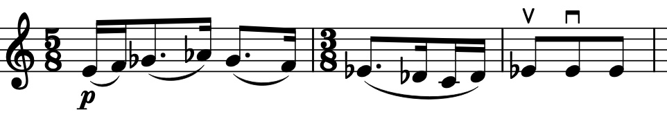
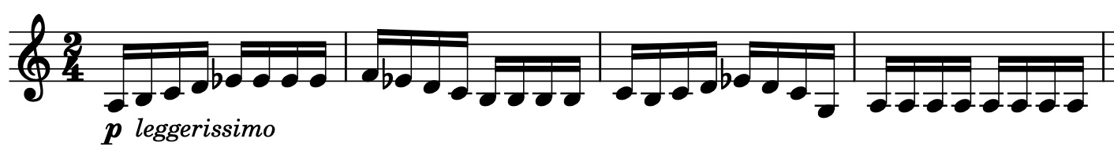
The second section starts with a long held muted D on the second violin; rapid 4-note upward interjections lead to the dance tune (illustrated) which is elaborated with powerful and complex rhythms and cross-rhythms which carry the music forward. This tune also links to a subsequent ingenious fugue (illustrated) that Stephen Walsh considers the best piece of fugal writing for string quartet since Beethoven’s Op.131. The pace quickens and eventually things fall apart with a series of sliding glissandi across all four instruments. This heralds the transition, over a long held cello note, into the third section.

The brief recapitulation regains the calmer more introspective mood of the first section. Its material appears in altered form, as if refracted through the turbulence of the intervening music. The final Coda section starts with fast sul ponticello semiquavers; the cello plays a rising-falling motif similar to the fugue subject above and the other instruments follow rapidly a few semiquavers behind. The dance theme reappears and things get wild, breaking apart again with huge glissandi and a sudden and rhythmically unexpected end.

