**Programme notes by Chris Darwin: Use freely for non-commercial purposes**

**Béla Bart́k (188881-1945) ttring Quuartet o o ) Op 17 (191)-17** *Moderato*

*Allegro molto, capriccioso*

*Lento*

In his early teens, Bartók was an extremely talented pianist and a budding composer. He took over from Dohnányi, who was 4 years older, as organist at the Catholic Gymnasium in Pozsony (now Bratislava). The young Bartók also enjoyed composing chamber music producing an early Piano Quartet and String Quartet in the general style of Brahms and Schumann. Aged 18 he followed Dohnányi to the Budapest Academy of Music to be taught composition by Hans von Koessler. Bartók flourished as a pianist, but failed to discover his own individual voice as a composer; his works were an amalgam of Brahms, Liszt and particularly Richard Strauss, all spiced with a little paprika. He made a piano transcription of *Ein Heldenleben,* and later, somewhat ironically, used it as a template for a successful, patriotic orchestral work *Kossuth*. But he was better known for his piano playing, and after graduating toured Europe extensively as a concert pianist.

The year 1904 was a turning point in his life. He was staying in a hotel in the north of Hungary finishing his Piano Quintet – a late-romantic show -piece – when he heard a Transylvanian-born maid, Lidi Dósa, singing in an adjacent room; he noted down her songs. From this happy encounter sprang a life-time of collecting folk song in collaboration with his contemporary, Zoltán Kodály. The collected materials in turn spawned Bartók's own voice as a composer, as he incorporated their characteristic melodies, harmonies and rhythms. The music that he collected was quite distinct from the 'Gypsy' music that had already permeated into Western art music (eg Haydn's 'Gypsy Rondo' Piano Trio) and which Bartók despised for adulterating 'true' Hungarian folk music.

The range of his knowledge of folk music was substantially expanded in 1906 when he took a break from a violin/piano recital tour of Spain to cross the Straits of Gibraltar, and heard Arabic folk music for the first time. In 1913 he returned to North Africa on a trip to Algeria, recording its Berber music on wax cylinders. The influence of this trip is very marked in the second movement of his Second Quartet, which he started in 1915. Its composition was paradoxically aided by WW1. Bartók was excused military service because of his poor health; both he and Kodály were entrusted with the collection of folksongs from soldiers, leading to a patriotic concert. But this still left time for concentrated composing, including the Second Quartet.

This quartet has just three movements and they are arranged unusually with a fast middle between a moderate first and a slow third. Kodály characterised them as "peaceful life – joy – suffering". It is certainly a work of huge physical and

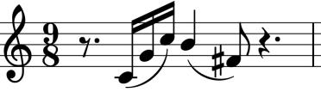

emotional contrasts. The Apollonian first movement ("peaceful life") contains some of Bartók's most beautiful sounds set in a carefully considered classical structure. It is dominated by an

easily recognisable, simple, breath-like, rising-falling phrase (illustrated). It contains the intervals of a fourth (here rising G->C and falling B->F#) and a semitone (falling C->B). These intervals are used extensively in this cleverly composed movement. For instance, the chord of the introductory opening bar (Bb – D – Eb) contains just these same two intervals.

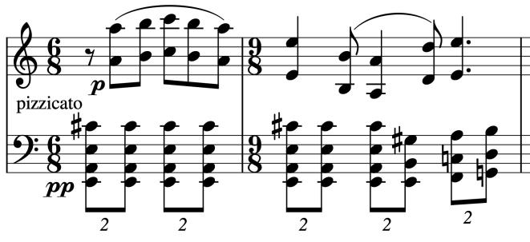A recurring structure in this movement is that the music builds in complexity and volume to a climax, dies down and then builds again. A contrasting, particularly peaceful moment comes with another arch-like phrase played in octaves; it returns later against the cello's strumming pizzicato (illustrated).

The percussive, wild, Bacchanalian second movement recalls the Berber music that Bartók had heard in Morocco and Algeria. After the attention-grabbing tritone-based first few bars the second violin starts a series of 159 insistently-repeated octave D quavers while the viola slaps pizzicato and the first violin barks out a wild song of repeated thirds decorated with sliding semitones. After a brief pause, we are off again, the first violin joining the second a tone higher for another 79 repeated octave quavers. Things get wilder, braking, accelerating, quizzically pausing before dashing off again even faster. Then suddenly - a different world: muted *pianissimo* and *prestissimo* (*really* fast – a virtuosic 8 crotchets a second) – the wild dancers ominously metamorphosed into Kafkaesque scurrying insects. Although *fortissimo* alternating thirds slam the door shut on this extraordinary movement, the world has changed.

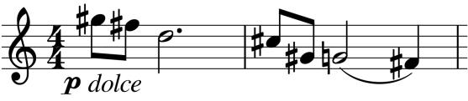

The last movement reminds us that the quartet was written during WW1. Anguished cries on a falling phrase ( *illustrated*) emerge from a seemingly arbitrary world of sighs. The music struggles to

break out into hope but to no avail. The cello's two *pizzicato* notes have the last despairing word.