Programme Note by Chris Darwin: please use freely for non-commercial purposes

**J.S.Bach (21 March 1685 – 1750) The Art of Fugue (c.1740 – c.1750 )**

*Contrapunctus I*

*Contrapunctus II*

*Contrapunctus VI in Stylo Francese*

Although many of Bach’s works were commissioned by his employers, two of his best known works, “The Well-Tempered Clavier” and “The Art of Fugue”, were not. They were exercises that Bach set himself in order to explore what was possible. The Art of Fugue consists of 14 completed and one apparently unfinished fugue, together with 4 canons all based on a single simple subject in D minor:

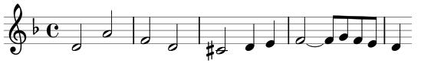

The structures that Bach creates from this simple material within the constraints of the fugal form are astonishing. For example, Contrapunctus XII is in fact two separate fugues that mirror each other. The notes played by the top voice of one are inverted (so rising intervals become falling) to give the bottom voice of the other. Bach writes the two pieces one above the other as if a mirror had been placed between them. The art of the possible !

What instruments was The Art of Fugue written for? Bach wrote it in “open scoring” with each part on a separate stave, and no indication of what instrument each stave corresponds to. Perhaps the work was simply written as an intellectual exercise that was not intended to be played. However, it was not uncommon at that time to write keyboard music this way, and the fact that the music *can* be played on a keyboard is reasonable evidence that it was intended to be so, unlike many of his ensemble pieces that cannot be played unaltered on a keyboard. In addition, as Gustave Leonhart has argued, not only did the range of the voices in the Art of Fugue not fit any contemporary ensemble, but also the types of fugue resemble those in the Well Tempered Clavier – a quintessential keyboard work. Although Bach may well have written the Art of Fugue so that it could be played on the keyboard, the music can be cunningly tweaked to make it playable by a string quartet. Compared to the harpsichord, the strings’ different tone colours and greater range of articulation and dynamic help the listener to follow the complexities of Bach’s astonishing contrapuntal lines.

Contrapunctus I is a simple 4-part fugue on the main theme and Contrapunctus II introduces a “French style” dotted rhythm accompaniment to the same main theme.

Contrapunctus VI is more complex. The cello starts with a dotted version of the main theme:

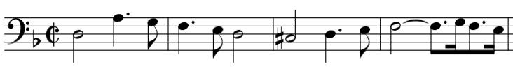

After the first bar the first violin enters with a double-speed variation of the *inverted* theme, which, of course, fits!

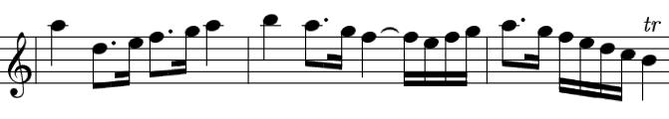

Jaunty dotted rhythms give a “French style” which is enhanced by rapid clusters of notes in one voice being answered by scintillations of very rapid notes in an answering voice.