Program Notes by Chris Darwin. Please use freely for non-commercial purposes.

**Grażyna Bacewicz (1909 -1969) String Quartet No.3 (1947)**

*Allegro ma non troppo*

*Andante*

*Vivo*

A virtuoso violinist, talented pianist and prolific composer, Bacewicz was born in Łódź ('the Polish Manchester') to a Lithuanian father and Polish mother. Her mother was an accomplished pianist and her father, a music graduate, was passionate about music. He taught Grażyna both piano and violin which she played in the family string quartet. After graduating in violin and composition from the Warsaw Academy, on the recommendation of Szymanowski and the financial support of Paderewski, she studied composition in Paris with Nadia Boulanger and subsequently violin with Carl Flesch. She had a brilliant international career as a solo violinist, frequently performing her own works. During World War II, she lived in occupied Warsaw giving secret underground concerts, only managing to escape together with her family after the 1944 Warsaw uprising. Composition became her sole occupation after a serious car accident in 1954. She wrote particularly well for strings and her works include 7 violin concertos, one for viola and 2 for cello, 5 sonatas for violin and piano and 2 sonatas for solo violin, 7 string quartets, a quartet for 4 violins and a quartet for 4 cellos, 2 piano quintets and 4 symphonies.

Diane Ambache, in her recent biography of Bacewicz, comments: *"Her interest in structure, motivic techniques, rhythmic energy, and fondness for contrapuntal textures overlapped with that of her contemporary Bohuslav Martinů (1890– 1959) and also of Paul Hindemith (1895–1963). Mid-period Bartók was another influence, which showed in her use of bracing and dynamic dissonances, and (naturally) the assimilation of folk music."*

Her String Quartet No. 3 was composed during a concert tour of France. Lutosławski said that it was *‘marked by an exceptional polyphonic skill in addition to its masterly idiomatic writing for string quartet’*. The work's opening has a vitality and rhythmic drive reminiscentof Martinů but very characteristic of Bacewicz, reflecting her energetic personality:

*"I possess a little unseen engine, and thanks to it I accomplish a task in ten minutes that it takes others an hour or more; I normally do not walk but I run; I speak fast; even my pulse beats faster than others and I was born in the seventh month. I was born for action, not for empty talk . . . There is only one essential needed: ‘motorek . . . ’ – without it don’t bother."*

The nervous semiquavers of the quartet's opening become the background to a slow lyrical theme (*illustrated*). This material is

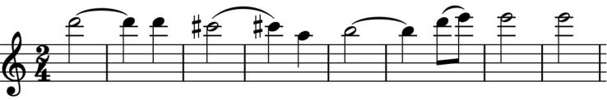

contrasted, after a high held C on the cello, with a waltz-like section, and these ideas are developed in a movement with a pleasingly compact, sonata-form structure.

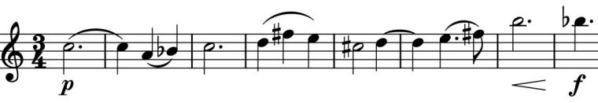

Slow movements are frequently the emotional heart of Bacewicz's music and this *Andante* has a serious

intensity enhanced by masterly string writing. The main theme (*illustrated*) has a pizzicato accompaniment that gives a characteristic rhythmic drive, followed by expert use of harmonics in building up novel chordal textures. It is an intriguing and effective movement which perhaps is an illustration of Bacewicz's view that *"... music does not express*

*anything; no ordinary emotions from human life. It simply expresses itself and its own affections."*

That said, it is hard not to see the boisterous last movement as capturing some of the spirit of Paris, where it was written, particularly in contrast with the privations of Bacewicz's homeland of soviet Poland. The almost continuous semiquavers of the first movement return in a different guise to support

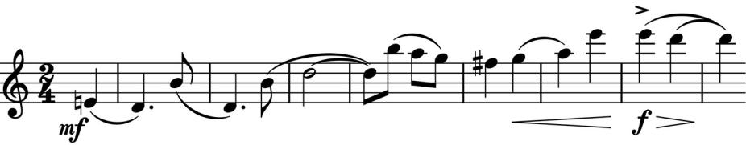

exuberant themes ( *illustrated*) and to carry the listener along on a ride packed with brilliantly varied string writing.

If you find you don't like Grażyna Bacewicz's music, you will be in interesting company. Diane Ambache again: *"(Bacewicz) had just given an inspired performance as the soloist in Karol Szymanowski’s Violin Concerto No. 1, when, on returning to the artist’s room, she found a small, unimposing man, who introduced himself as the Custodian of the Museum of String Instruments. He said that quite often he played one of her violin compositions, and he explained why: ‘I discovered some woodworm in one of the old instruments so I take all the violins in turn and play your piece. The woodworm do not like your music and run away in panic. I came to thank you.’ "* More sophisticated listeners find her music"*appealing in its vitality, naturalness, and directness".*

If you are not familiar with Bacewicz's music, there is an excellent 50 minute introduction: a Radio 3 ‘Composer of the Week’ highlights programme, available for download at [www.bbc.co.uk/programmes/p02sln1f](http://www.bbc.co.uk/programmes/p02sln1f).