Programme notes by Chris Darwin. Please use freely for non-profit activities

**Juan Crisóstomo de Arriaga (1806–26)** String Quartet No. 1 in D minor (1822) *Allegro*

*Adagio con espressione*

*Menuetto (Allegro) and Trio (Più moderato)*

*Adagio – Allegretto*

Arriaga, known as the 'Spanish Mozart', was born in Bilbao on what would have been Mozart's 50th birthday. By the age of 10 he had written an octet and was playing second violin in a professional quartet. Like Mozart, his first opera was written at 13. His merchant father had the means to nurture his son's prodigious musical talent, sending the 16-year-old to the Paris Conservatoire to study with Cherubini. That year he wrote his three string quartets which were the only pieces to be published during his lifetime. The following year he wrote a *Stabat Mater* which drew the comment from Cherubini: "*Amazing*

* *you are music itself*." His teachers were astonished at Arriaga's ability to use sophisticated musical techniques without having been taught them. He became celebrated, but tragically died in Paris of a lung infection a few days short of his 20th birthday.

His first quartet is in D minor, the key of Schubert's '*Death and the Maiden*' written two years later. It shows well Arriaga's gift for melody, his unexpected rhythmic swerves and his deft handling of counterpoint and harmony with a fully liberated cello. Aged 16, Arriaga has an astonishing overall mastery of the string quartet - a much more difficult medium than the string octet which Mendelssohn (three years his younger) so successfully wrote for at the same age.

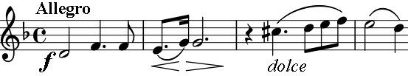

The work opens boldly with 2 bars of dark unison and a *dolce*, harmonised, 2-bar reply. Four bars later the whole phrase

becomes *dolce,* and a few bars later still we have wild semiquavers evocative of adolescent passion. These restless

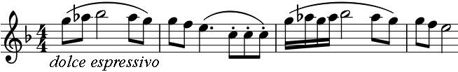

mood swings continue throughout the movement. Arriaga's Spanish heritage appears clearly in the expressive second subject, heard initially on the

first violin and then on the second with asides from the viola. This contrasting material is developed and reprised before a shift to the major for the final thirty or so bars.

The second movement is built on an almost static opening: an introductory held chord followed by pairs of slow crotchets separated by rests. The first violin reveals the continuing melody, and the sense of movement

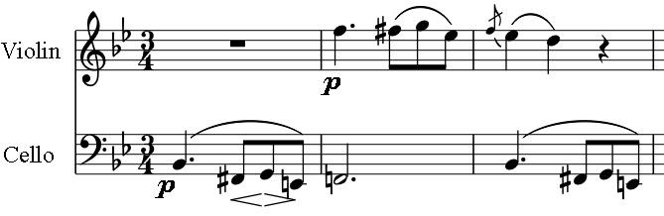

increases as the inner parts break into semiquavers that accompany the start of a poignant dialogue (illustrated) between the cello and the first violin. The dialogue continues through much of the movement with the first violin's rhapsodic decorations echoed

by the cello. The Minuet and Trio are conventionally structured; the stylish Trio has the flavour of a spanish dance.

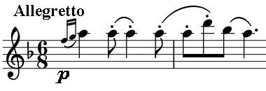

The last movement starts with a slow introduction which gives way to an *Allegretto* spanish dance, reminiscent of the Siciliana last movement of Mozart's D minor quartet (K.421). The stately soon gives way to the wild, with another

adolescent outburst; but Arriaga's natural musicianship keeps control and leads us to a delightful, contrasting theme from the viola. The

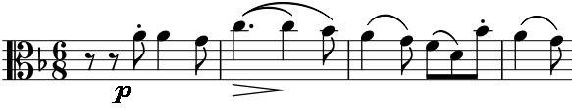

slow introduction is reprised, and the viola's tune introduces a section in the major. The coda returns to the minor and this precocious work ends with stylish understatement.