**Programme notes by Chris Darwin. Use freely for non-commercial purposes**

**Anton Arensky (1861-1906) Piano Trio No 1 in D minor, Op 32 (1894)**

*Allegro moderato*

*Scherzo (Allegro molto)*

*Elegia (Adagio)*

*Finale (Allegro molto)*

Arensky came from an affluent, musical family in Novgorod: his father was a keen cellist and his mother an excellent pianist. He was already composing aged 9, and at 16, after the family had moved to St Petersburg, he started to study composition with Rimsky-Korsakov at the St Petersburg Conservatory. Three years later, after graduating with a gold medal, he secured a professorship in harmony at the Moscow Conservatory where he was actively encouraged and helped by Tchaikovsky, and in turn taught Rachmaninoff, Skryabin and Glière. Tchaikovsky's influence on his developing style was not to Rimsky-Korsakov's liking; he later wrote: "In his youth Arensky did not escape some influence from me; later the influence came from Tchaikovsky. He will quickly be forgotten." Ouch.

Arensky's music did go through a period of neglect, perhaps because he was not seen as having a sufficiently distinctive voice, but tonight's D-minor Piano Trio is one of his works that now enjoys deserved popularity. Its third movement is an elegy dedicated to the memory of Karl Davidoff, mathematician, composer and 'the Tsar of cellists'1 (Tchaikovsky), who was head of the St Petersburg Conservatory. Elegiac piano trios were booming at that time in Moscow. Tchaikovsky's 1882 Piano Trio was written in memory of Nikolai Rubinstein; Rachmaninov wrote two, one in 1892 as a tribute to a still-alive Tchaikovsky, and the second in 1893 following Tchaikovsky's death; Arensky's trio came the following year.

As well as showing the influence of Tchaikovsky, the Arensky Trio also recalls Mendelssohn particularly in

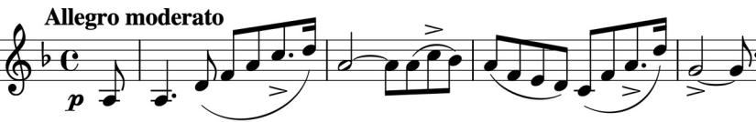

the confident forward movement of its opening theme. The second movement is a skittish *Scherzo* contrasting with a warmly affectionate *Trio*.

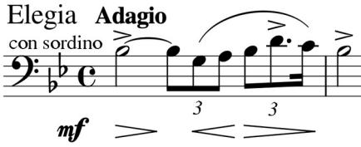

After the poignant *Elegia* with its sobbingly held dotted triplet (illustrated), the *Finale* is nervously unsettled, its *Allegro molto* anxiety only temporarily relieved by anoptimistically *Andante* version of the *Elegia* theme in the major; this soon reverts to the original mournful minor,

before the fretful *Allegro molto* returns to face a future without Davidoff.

Arensky himself died of tuberculosis aged 44. Little is known of his personal circumstances, though Rimsky-Korsakov gives the perhaps jaundiced view that gambling and drink had undermined his health from an early age. An antarctic glacier is named after Arensky; it and the Alyabiev (another Russian composer) flow south from Beethoven Peninsula into the north end of Boccherini Inlet.



* Incidentally, Davidoff was given a Stradivarius cello that now bears his name; it was subsequently owned by Jacqueline du Pré and is now played by Yo-Yo Ma.