**Programme note by Chris Darwin. Use freely for non-commercial purposes**

**Elfrida Andrée (1841-1929) Piano Trio No. 2 in G minor (1883)**

*Allegro agitato*

*Andante con espressione*

*Finale. Rondo Allegro risoluto*

Elfrida Andrée was a pioneer for the rights of women. She was the first woman in Sweden to graduate as an organist, and, after she and her liberal, physician father had been instrumental in changing the law, the first woman cathedral organist (at Gothenburg). Her father had met at London's 1851 Great Exhibition women who were both organists and also managed telegraph stations, so he and Elfrida also got Swedish law changed so that Elfrida became one of the very first Swedish women telegraphists. This was at a time when her initial attempts to become a church organist had been rebuffed by: *‘the sight of a woman on the organ stool [would be] indecorous and disruptive of devotion’* and *‘Paul has said "Let your women keep silence in the churches"’* . Towards the end of her life, whenstill at Gothenburg, she enjoyed playing late into the night at full volume on the now electrically-pumped organ. One evening as the final blast died away she was heard to remark : *‘Paul, old lad − try that for size!’.* Incidentally, Gothenburg Cathedral was a Schartauan bastion, which meant that the somewhat secular Andrée had to endure sermons lasting for hours, with extensive depictions of severe punishment for sins raining down over the congregation.

In the early 19th century, Swedish women had composed songs but none had written any major composition. In the 1860s Andrée composed several chamber music works and submitted, anonymously, a piano quintet to the Swedish Art Music Society. It was accepted and published in 1865. There was great surprise when it became known that the ‘man’ behind this composition was a woman. Her substantial musical output includes an opera, 2 each of symphonies, string quartets, piano trios and violin sonatas, a piano quartet and quintet. Securing adequate performances for her major works was not easy. She and her sister walked out at the start of the last movement of the premier of her first symphony in 1869 when the first violins persisted, in Andrée's view intentionally, in playing a bar behind the rest of the orchestra. Reviews were predictably and quite unfairly scathing.

Stylistically, much of Andrée's music, including tonight's piano trio written towards the end of her composing career, owes much to Mendelssohn. She had spent the spring of 1872 in Leipzig after having impressed Mendelssohn's erstwhile Leipzig colleague the Dane Niels Gade with her first symphony. Her trio combines the lyrical fluency of Mendelssohn with the robust energy of a composer who was definitely her own woman.

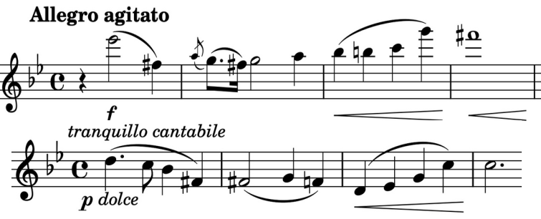

That energy is evident in the forceful opening theme (*illustrated*) with its initial bold falling seventh and also in its subsequent sprightly quaver partner. We then get the contrast of

* lovely, calmer, *tranquillo cantabile*, theme (*illustrated*) which is clearly derived from the opening. These

three themes provide abundant material for Andrée to develop and reprise with passion and skill.

The *Andante* slow movement's tender opening theme (*illustrated*) also gains poignancy from the interval of the seventh, first

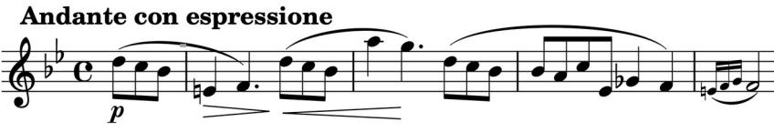

across the opening four notes falling from D to E natural and then a bar later rising from B flat to A. Contrast then comes, as in the first movement, from a quaver figure, this time with an added dotted rhythm (*illustrated*).

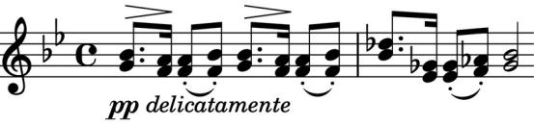

The Finale is a lively Rondo with a

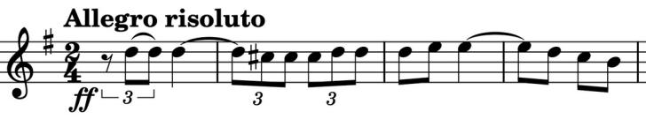

recurring motif of rhythmically

opposed triplets and duplets

(*illustrated*), contrasting with more

lyrical episodes.

It has been a real pleasure playing and listening to this piece. I hope you enjoy it too. My debt to an excellent biography of Andrée by Eva Öhrström at [https://www.swedishmusicalheritage.com](https://www.swedishmusicalheritage.com/) will be obvious to those who read it.