**Program note by Chris Darwin: use freely for non-commercial purposes Thomas Adès (b.1971) The Four Quarters (2010)**

*Nightfalls*

*Serenade: Morning Dew*

*Days*

*The Twenty-fifth Hour*

Thomas Adès takes notes seriously. For him they are magnetic: *"the two notes in an interval... have a magnetic relationship of attraction or repulsion which creates movement in one direction or another"* (in conversation with Tom Service). The composer has to find where the notes want to go, exploring their inherent instability. Adès admires composers who respect their material in this way: Beethoven, Haydn, Janáček, Sibelius.

And it is worth taking the *"prodigously talented"* (NYTimes) Adès seriously - as an academic (double starred first from King's College, Cambridge), pianist (second in Young Musician of the Year and internationally renowned performer), percussionist and of course composer. Operas and a wide variety of other vocal, orchestral and chamber music have established him as perhaps the best known British composer of his generation.

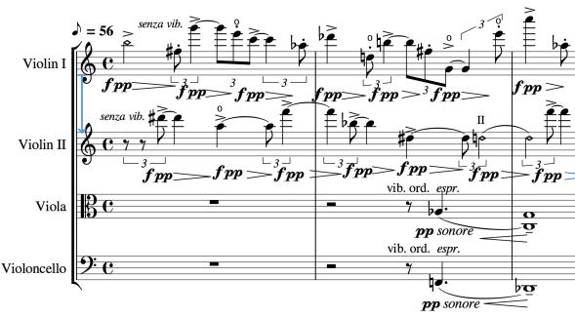

*The Four Quarters* follows *Arcadiana* (1994) as Adès' second string quartet. The first quarter, *Nightfalls*, opens with a texture popular with Adès – very high combined with very low. The two violins alternately scintillate like twinkling stars while the viola and cello growl like the body of the earth settling down for the night (illustrated): two separate worlds together. A

slow violin melody builds through organ-like chords to a climax which then fades back to the scintillating world of the opening. The second movement's *'Morning Dew'* scintillates in a different way with technically demanding *pizzicato* in continually changing, arithmetically daunting time signatures.

Like the *Scherzo* of the Beethoven quartet later in today's concert, '*Days*' opens with a simple, repeated rhythm (lasting

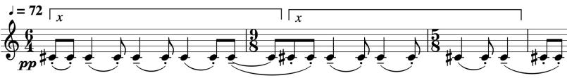

13 quavers) on a single note (illustrated *x*). Adès complicates things by writing the rhythm

across bars of changing time signature. The second violin persists with the rhythm against growing harmonies from the other instruments until first the viola takes it over and then the whole quartet shouts the rhythm *fortissimo,* before dying down, but with that rhythm still persisting.

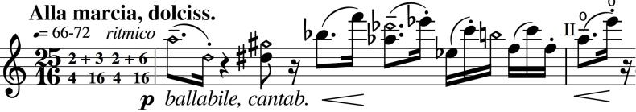

The final movement '*The Twenty-Fifth hour* ' has a fiendishly complex, eponymous time

signature – 25 semiquavers to a bar (8+3+8+6) – which Adès asks to be played *'very sweetly, like a march and dancingly, like a song'*. Fortunately, we listeners are largely unaware of the dense technical problems facing the performers: Adès' music engages with fascinating and often beautiful sounds. To paraphrase a remark attributed to quantum mechanic Richard Feynmann *"If you think you understand Tom Adès, you don't understand Tom Adès."* The end of the movement returns to the sound world of the work's

opening, resolving all the previous complexities to a simple D major chord combining three very low with two very high notes.