Programme notes by Chris Darwin. Use freely for non-commercial purposes.

Dmitri Shostakovich (1906-75) String Quartet No 10 Op 118 in A-flat (1964)
Andante
Allegretto furioso
Adagio
Allegretto

In contrast to his fifteen symphonies, which were very public and closely monitored by the state, Shostakovich’s quartets allowed for more intimate, personal expression, particularly when he writes for a single voice against an often sparse background. The quartets are essentially dramatic. “There’s an opening, the lights come up. Often things start in a Chekhovian way, without too much conflict, with people discussing inanities – innocently unfolding.” (Philip Setzer of the Emerson Quartet). But as with Chekhov, conflict subsequently breaks through as in the second movements of the tenth quartet. The apparent calm of the openings may return towards the end of the quartets, but enigmatically transformed.

Shostakovich’s tenth quartet is dedicated to Mieczysław Weinberg. Born in Poland to Jewish parents, Weinberg fled to the Soviet Union at the outbreak of the second world war and shortly afterwards met Shostakovich. They became very close friends, sharing compositions and political outlook. Weinberg was very important to Shostakovich and a letter from him to Beria probably saved Weinberg from being executed by the state on trumped-up charges. They had a bet as to who would complete the most quartets; until this tenth quartet they were at nine all, so the dedication to Weinberg has a touch of competitive edge to it.

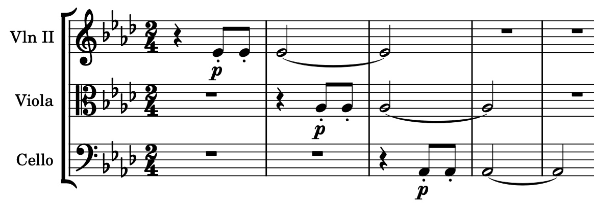
The quartet is “at once Shostakovich’s harshest string quartet and his friendliest” (Wendy Lesser). It has the peaceful Chekov-like opening mentioned above with a solo violin being reassured after a dozen bars by three repeated notes from its friendly fellows (illustrated). But the first movement introduces an Allegretto furioso of unequalled and unrelenting fury – the first half consistently ff, the second consistently fff. The more autobiographical eighth quartet has a similarly angry second movement but there the fury is relieved by something a little lighter. Perhaps injustice to one’s friends is harder to come to terms with than injustice to oneself.
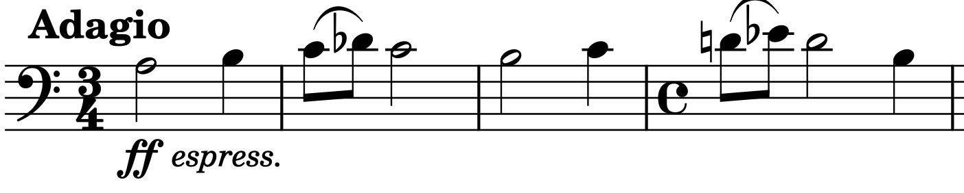
There follows a Passacaglia on a 9-bar theme announced ff on the cello (illustrated). Its eight graceful and calm variations lead directly into the jaunty rondo viola theme of the substantial last movement. The movement’s uncomplicated nature does not last as a wide range of preceding material is revisited. Finally, the work’s opening theme returns in the cello, playing against the rondo theme as the music fades away.

