Programme Note by Chris Darwin: please use freely for non-commercial purposes

Wolfgang Amadeus Mozart (1756-1791) String Quartet in C major K.465

(Dissonance) (1785)

Adagio – Allegro

Andante cantabile

Menuetto & Trio – Allegro

Allegro

Mozart’s “Dissonant” quartet is the last of the famous set of six quartets that Mozart dedicated to Haydn – the A major K.464 from this set was played earlier this season by the Chilingirian Quartet. The set was inspired by Haydn’s six Op 33 quartets that had appeared in 1782, encouraging Mozart to a “long and laborious study” which eventually gave birth (between 1782 and 1785) to these “six sons”. This last quartet of the six is the best known and, like the A major quartet, demonstrates how much Mozart had learned during his long study.
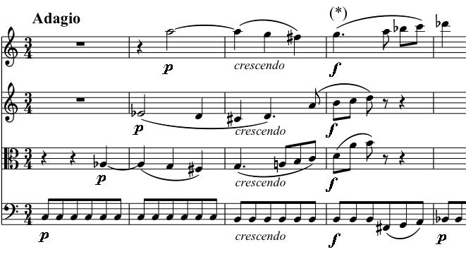

The Dissonant epithet refers to the extraordinary opening bars. The cello at first gives nothing away, pulsing on the tonic of the innocuous home key of C major. The viola enters on an Ab and the second violin on an Eb, making an Ab major chord and then the first violin comes in a

semitone too high on an A natural just as the viola drops from Ab to G, leaving us in C minor with an added (A) sixth, and we haven’t finished the second bar yet! Even to our 21st-century ears it surprises. No wonder some early commentators suggested that Mozart’s text contained uncorrected errors. These few bars provide source material for the whole quartet: the pulsing base, staggered entries, semitone clashes and a sliding rising figure (*).
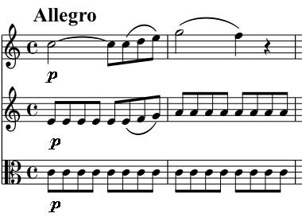

For example, the solidly C-major opening phrase of the Allegro is a non-chromatic version of this rising figure, together with the pulsing base. Mozart uses this figure to lead us into yet more wonderfully remote keys in the development section.

The Andante opens with a tender theme on the first violin, whose ending becomes a simple little figure that the violin repeats and is each time lovingly echoed by the

cello. There is then a magic pianissimo passage that, like the introduction, has a gradual build-up of instruments above the moving cello, but without its challenging dissonances. But just
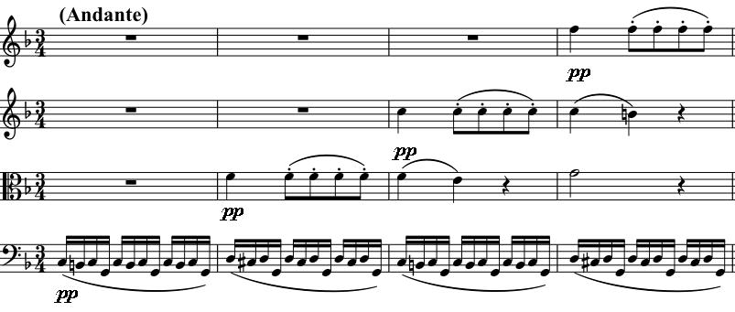
wait; when this passage returns shortly before the end of the movement, it crescendos to forte as the first violin produces a striking semitone

dissonance like the one we heard in the introduction.

The Menuetto is based on the chromatic sliding quavers that the first violin opens the movement with and which are also based on the asterisked (*) figure in the first musical example. The Trio though starting piano is in an irate C minor, with incessant accompanying repeated quavers and forte outbursts. The sun returns in the last movement, whose opening theme again includes those rising, sliding semitones. All the instruments enjoy the contrapuntal fun of this movement, and then as the piece is ending, the coda shows us, as in so many of Mozart’s works, just a few of the other things he could have done with this material.

One of the joys of playing this set of quartets for a violinist / violist is to take a different inner part of a quartet that you thought you knew well, and discover the exquisite detail that Mozart produced in his “long and laborious study”. As you listen to this piece try following one of the inner parts and hear why string players are so grateful to Haydn for stimulating Mozart to write these quartets!

