Programme notes by Chris Darwin, use freely for non-profit activities

W.A. Mozart (1756-1791) Serenade No. 12 in C Minor, K. 388 (1782)

Allegro
Andante
Menuet & Trio
Allegro

This Serenade was written during the boom years of 'Harmoniemusik' – music written for a court (or, less sophisticatedly, a military or street) wind band, generally as background music to dining or other socialising. An operatic example of Harmoniemusik comes during dinner in Don Giovanni when a Harmonie plays an arrangement of an aria from Figaro. Such aristocratic bands arose in the mid-18th century, and declined in the austerity years of the Napoleonic wars. The Harmonie's instruments came in pairs: at the core a pair of horns, underpinned by bassoons and overlaid by some combination of flutes, oboes, clarinets, basset horns, and cors anglais. There were usually 6 or 8 of these paired players along with an optional deep bass provided by a trombone, double bassoon, shawm or string bass.

Mozart wrote two early (1773) Divertimenti for a 10-piece Harmonie in Milan followed by five more in Salzburg for the more usual sextet (two each of oboe, bassoon, horn) - all light and witty, undemanding of the listener. Today's C minor Serenade was one of three much more substantial Harmonie Serenades, including the Gran Partita, written in 1781-2. It is scored for two each of oboes, clarinets in Bb, horns in Eb, and bassoons. Five years later, Mozart transcribed the work for two-viola string quintet retaining the key of C minor (K. 406). The wind Serenade's dark mood and technical sophistication raise the possibility that it was intended for a more discerning audience than the usual "Night music Serenade".

As befits a work in C minor, this Serenade is full of dramatic contrast, bearing out Alfred

Einstein's observation: 'If G minor is the fatalistic key for Mozart, then C minor is the
dramatic one, the key of contrasts
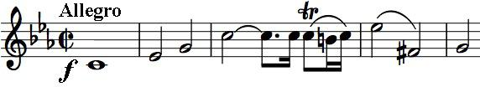
between aggressive unisons and lyric
passages. The lyric quality is always
overtaken by gloomy outbursts.' The
opening is just such an aggressive unison.
The second movement banishes aggression with 'the moonlit tones of an operatic love scene'. But the Minuet returns to a harsher intensity; it is simple enough, a strict canon with the two voices playing the
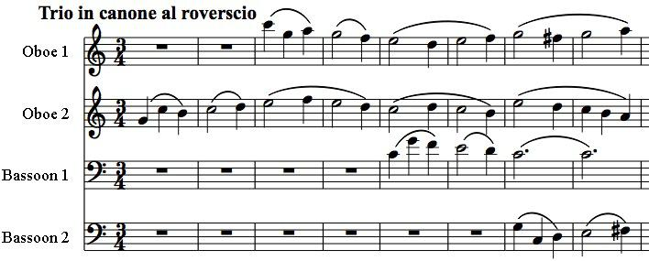
same music a bar apart. The milder Trio now plays a musical game of mind-boggling complexity. An oboe starts a theme; the other enters two bars later with the same theme turned upside down. Two bars later a bassoon enters with a slightly altered version of the original
theme, and a further two bars later the other bassoon enters with its upside-down version. All this wizardry is done with the lightest touch – most enjoy it oblivious to its technical brilliance. See if you can hear what happens in the second half of the Trio!

The Serenade ends with a set of variations on a theme announced by the oboe. The variations are notable for the variety of their textures and not least for the athleticism required of the bassoons; at the end the C minor clouds clear for a joyously major ending.

