Program Notes by Chris Darwin. Please use freely for non-commercial purposes.

Witold Lutos!awski (1913-1994) Subito for violin and piano (1992)

This short (4-minute) piece was almost the last that Lutos!awski completed. His life was moulded by two world wars. His father, a cultured Polish estate owner, was executed in Moscow's Lublyanka by the Bolsheviks in 1918. Witold himself was captured by German forces in 1939, but escaped after only a week. He spent the rest of the war in Warsaw earning an illicit living playing in cabarets and giving concerts, some in a piano duo with fellow composer Andrzej Panufnik. During the subsequent Stalin era Lutos!awski met its constraints by writing music for which there was a social need, "functional" music, into which he incorporated elements of folk music. His popular Concerto for Orchestra (1954) dates from this period. Post Stalin, he developed a personal twelve-tone style, beginning with Funeral Music (1958) composed in memory of Bartók. A third phase was inspired by hearing a work by John Cage; Lutos!awski's compositions began to incorporate elements of random choice by the players. From the 1970s on, he became increasingly recognised internationally, with many prizes and commissions from leading performers.

Subito was commissioned by Joseph Gingold for the 1994 International Violin Competition in Indianapolis. Lutos!awski had learned the violin as a child and in 1984 had been inspired to compose for the violin by the playing of Anne-Sophie Mutter. He enjoyed the "functional" challenge of a piece that showed off the competitors' virtuosity. Subito's title has been associated with its 'out of the blue' start
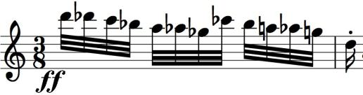
(illustrated) and abrupt mood changes. The mood changes may also reflect his own emotional turmoil: he had been recently diagnosed with the
cancer that prevented him from completing a violin concerto for Mutter.

The opening few bars of Subito form a refrain that alternates four times with varied episodes. With each repeat the refrain gets shorter and the episodes more complex. A long high trill marks the climax and the piece ends with another version of the refrain.

