Programme notes by Chris Darwin. Use freely for non-commercial purposes
Joseph Haydn (1732-1809) Piano Trio in E, Hob. XV:28 (1797)

Allegro moderato
Allegretto
Finale. Allegro

It is easy to undervalue Haydn's Piano Trios. The string parts often double the keyboard and generally lack the independence found later, say in Beethoven. But for much of his piano trio output, Haydn's hands were tied by the underpowered keyboards that he was writing for – doubling of the weak keyboard bass line was a necessity. Viewed on their own terms as 'keyboard sonatas with string accompaniment', we can enjoy their virtues rather than wishing they were Beethoven.

Charles Rosen devotes a whole chapter of "The Classical Style" to Haydn's piano trios encouraging us to see them as a "third great series of works to set beside the symphonies and the quartets". They fall into two main groups: 16 or so early trios composed between about 1760 and the early 1770s, and the latter 27 or so composed between 1784 and 1797. In all of them Haydn is surprising and inventive. In the earlier trios his natural extraversion sits well with the excesses of the contemporary Mannerist style – as in say C.P.E.Bach. But in Haydn's later trios his creative exuberance acquires new significance as it is constrained by the structures of the newly emerging Classical style.

The E major trio, is one of three dedicated to the virtuoso pianist Theresa Jansen Bartolozzi whom he had met in London. It is one of the last trios he wrote (around the same time as the Op 76 string quartets), and exploits the more powerful Broadwood pianos that were then available in England. It is a work of extraordinary inventiveness and surprise. Why did Haydn write no more piano trios after this set? Partly because he left London with its talented pianists and forceful Broadwoods, but also perhaps it is no coincidence that Beethoven's revolutionary three Op 1 piano trios had appeared two years earlier in 1795. Haydn knew when he had been overtaken.

The start of the E major trio is a surprise: pizzicato in the strings with staccato piano bass gives us piano trio as harp accompanying the piano's cantabile right hand melody. After the repeated first half Haydn has some modulatory fun. Starting from the home key of E (4-sharps) he moves to a climax in the unwritable 8 sharps of G-sharp, so enharmonically slips the key-signature into the 4 flats of A-flat for a few bars, kindly spelling out to the string players that their held Ab/G# across the key-change is in fact "the same note".
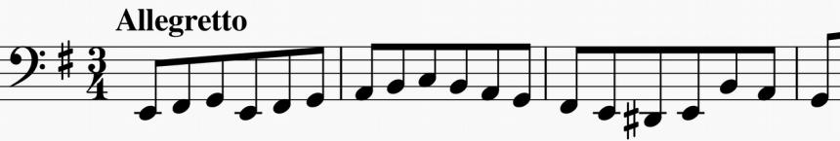

The opening of the E-minor second movement is no less surprising: again the piano has the melody but this time

introduced by a creeping Bach-like bass line played in octaves by all three players
(illustrated). If you heard this passacaglia-like movement in isolation would you think it was by Haydn? Charles Rosen describes this extraordinary movement as being baroque, classical and romantic.

The last movement tries to unseat you with its quirky rhythms and gives us more modulatory bravura when, in the central E-minor section, Haydn plays a Beethoven-style trick and, after a pause, just drops a semitone to get into E-flat minor for just 4 bars. It should be in 6 flats, but he writes it in 4 flats (again). Weird. One suspects a private joke with Mrs Bartolozzi.

