Programme notes by Chris Darwin: Use freely for non-commercial purposes
Josef Haydn (1732-1809) String Quartet in D, Op.76 No.5 (1797)
Allegretto
Largo ma non troppo. Cantabile e mesto
Menuetto. Allegro
Finale. Presto
In 1795 Haydn returned from his spectacularly successful visits to England to the relatively light duties prescribed by the new Esterházy Prince Nikolaus II. Nikolaus had abandoned his father's palace at Esterházy, sacked its extensive musical establishment, and divided his time between Eisenstadt and Vienna. Haydn was kept on, but his main duty was just to write a Mass for the Princess's name day. He was free to accept other commissions. One such came from Count Joseph Erdödy, the Hungarian Court Chancellor.
Although Erdödy's father had employed an orchestra to play in their family's three palaces, on inheriting the title in 1789 his son responded both to contemporary taste and financial stringency by replacing the orchestra with a string quartet. In 1796 he placed a generous commission with Haydn for six quartets. The resulting 'Erdödy' quartets are a triumph, perhaps the pinnacle of Haydn's long quartet-writing career.
The overall form of the fifth quartet is unusual, as one might expect from Haydn - the genre's creator. Quartets usually have a first movement that is in sonata form; the middle movements tend to be a slow movement, which may be a set of variations or something more rhapsodic, and a minuet or scherzo. The final movement is often a fast movement in rondo form with a theme returning after each of a variety of sandwiched episodes. In this quartet though the first movement is a series of variations on a siciliano theme, the slow movement and the last movement are in sonata form, and only the Minuet obeys the rules.
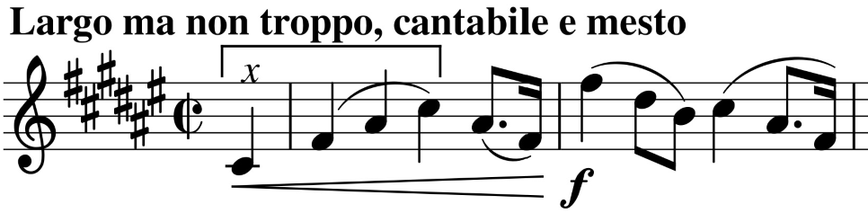
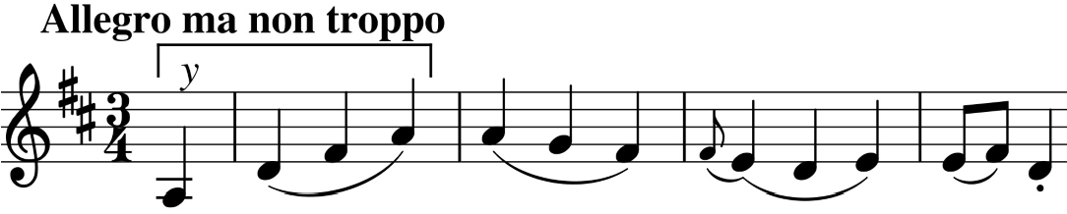
The opening themes of the second and third movements (both illustrated) are closely linked: they start with the same sequence of four notes (under x & y) - a rising triad in the home key starting on the dominant. The Largo slow movement starts on an upbeat C# on the violin which you might think would lead into the home key of D; but no, this is Haydn and it turns out we are in F# major – the sharpest key signature in all his chamber music. After a pause, the slow movement continues with what Hans Keller described as 'the deepest viola solo in all Haydn' accompanied by the violins' ethereal linked quavers. The cello takes over and leads us gloomily down through semitone modulations to pause again, now, briefly, in the even sharper C# major. The violin recaps the theme in the home key, lifting the clouds.

