Program Notes by Chris Darwin. Please use freely for non-commercial purposes.

César Franck (1822-1890) Sonata for violin and piano in A (1886)
Allegretto ben moderato
Allegro
Recitativo – Fantasia: Ben moderato
Allegretto poco mosso

César or, to give him his full gloriously quintuple-barrelled forename, César-Auguste-Jean-Guillaume-Hubert Franck, had his early career shaped by a combination of innate musical talent, and an overbearing father – a Walloon mine superintendent. His father exploited César's prodigious talent as a pianist, sending him and his violinist brother on well-paid concert tours at the expense of his education at the Paris Conservatoire. His early compositions were showy piano pieces written for such tours, but aged twenty he wrote four piano trios, which secured his reputation as a composer. However, for much of his life he was forced to earn his living quartering Paris as a piano teacher during the week and as a church organist at week-ends. He was also a much-loved teacher of composition both individually and as professor of organ at the conservatoire. Most of his own composition was for organ and, less successfully, for choirs. He did not return to writing chamber music until his later years: the piano quintet in 1879, tonight's sonata in 1886 and the string quartet in 1889. These works are of his best, and established a new era of French chamber music.

The Violin Sonata was written when Franck was 63, as a wedding present for the 31-year-old Belgian virtuoso violinist and composer Eugène Ysaÿe. Franck presented the work to Ysaÿe on the morning of his wedding. After a hurried rehearsal, Ysaÿe performed the Sonata at the wedding. He gave the first public performance later that year at the Brussels Museum of Modern Painting. By the end of a long programme, the light was fading, and since the gallery authorities permitted no artificial light, the last three movements had to be played from memory in virtual darkness.

There is some evidence that the origins of the work lie in a sonata for cello; Franck certainly authorised a subsequent arrangement for cello. One characteristic of his style that can be seen in the sonata is his use of 'cyclic unity' where ideas from previous movements re-appear, perhaps modified, in later ones. The violin's opening theme of the gentle first movement (illustrated) provides a foundation for
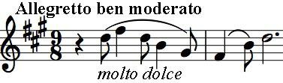
the whole work. The following Allegro is more like a conventional first movement, an energetically rising start contrasting with a falling second subject that mirrors the
work's opening figure. The third movement is an original Recitative and Fantasy whose opening echoes that of the first movement and whose climax introduces both a theme (illustrated) which will recur in the last movement and another that provides a variant on the work's opening. Much of the final
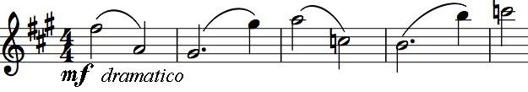
movement is written as a canon on a theme (illustrated) which is again related to the work's opening. The two parts of
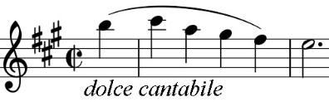
the canon are initially separated by a whole bar, but later move closer to just a half bar – a touching metaphor, along with the hint of wedding bells, for Ysaÿe's wedding.

