Programme notes by Chris Darwin; use freely for non-commercial purposes.

Antonín Dvořák (1841-1904) Piano Quartet in D, Op. 23 (1875)
Allegro moderato
Andantino con variazioni
Finale. Allegretto scherzando

In 1875 Dvořák was on the edge of a breakthrough in his career. His compositional style had been based on the German romantics such as Mendelssohn and Schumann, and then Wagner. In 1871 he was working on an opera ‘King and Charcoal Burner’ which a Prague theatre promised to produce. However when rehearsals began two years later it rapidly became clear that the work was so influenced by Wagnerian principles as to make almost insuperable demands on the Prague singers and players alike. The production was cancelled. Dvorak took this rejection seriously, destroying many works from his 'mad period'. He moved his style away from contemporary German to a simpler, classical one which importantly incorporated Slavonic folk music. He completely rewrote ‘King and Charcoal Burner’ in 'national rather than Wagnerian' style and it was very successfully premiered in November 1874.

To supplement his meager income from teaching, in 1874 Dvořák successfully submitted works for an Austrian National Stipendium. In 1877 a subsequent application was reviewed by a committee that now included Brahms who was eight years older than Dvořák and well-established. Brahms was so impressed by one of Dvořák's submissions
– 10 Moravian Duets for 2 sopranos and piano - that he wrote to his publisher Simrock urging him to publish the Duets along with more of Dvořák's work ('He is a very talented man. Moreover he is poor!'). Brahms' and Simrock's support transformed Dvořák's career. Almost overnight he became famous – and richer.

Curiously, a few years later Dvořák returned to a less nationalistic style as a result of a commission from the Vienna-based Hellmesberger Quartet – Czech nationalism was no longer welcome in Vienna either politically or musically.

The nationalistic Czech folk style, elements of which Dvořák learned from Smetana and friends such as Janáček, contains for example: pentatonic phrases, a sharpened fourth in the minor, strong syncopation and often an absence of an upbeat to a melody, reflecting the Czech language's stress on a word's first syllable. The opening cello phrase of tonight’s piano quartet (see below) is an example of a rhythm which looks like it might start with a quaver upbeat, but the quaver is actually the downbeat, followed by syncopation.

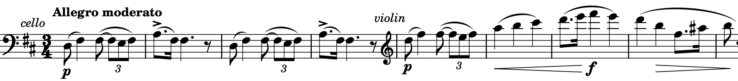
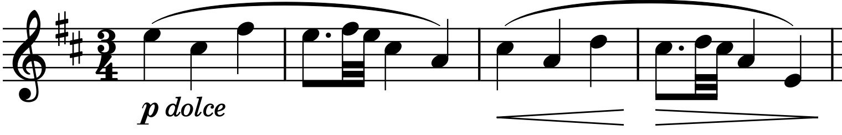
The first movement, in sonata form, is built around two contrasting folk-like melodies, the first (illustrated) with the cello introduction we have just mentioned. It contains (bar 2) a descending, dotted rhythm figure which recurs prominently in the movement. The second theme (illustrated) makes a genial contrast throughout this extensive movement.

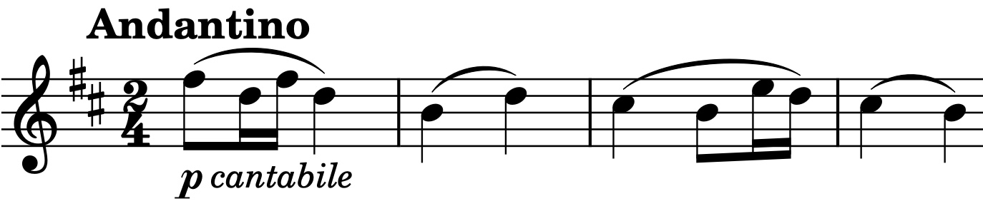
The second movement is a set of 5 variations and coda on a theme (illustrated) that moves from the minor to the major.

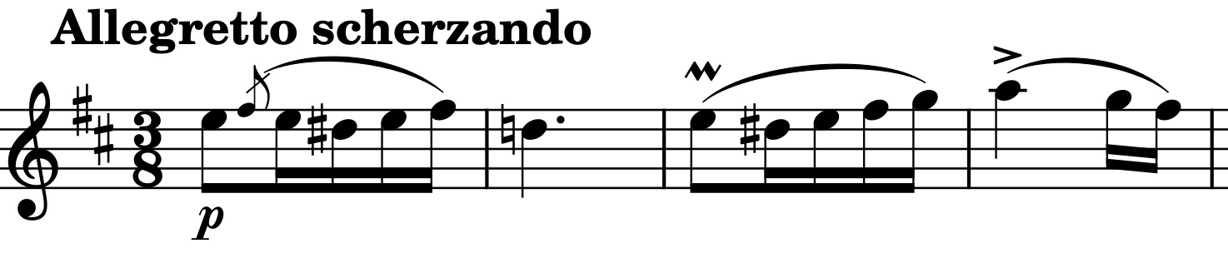
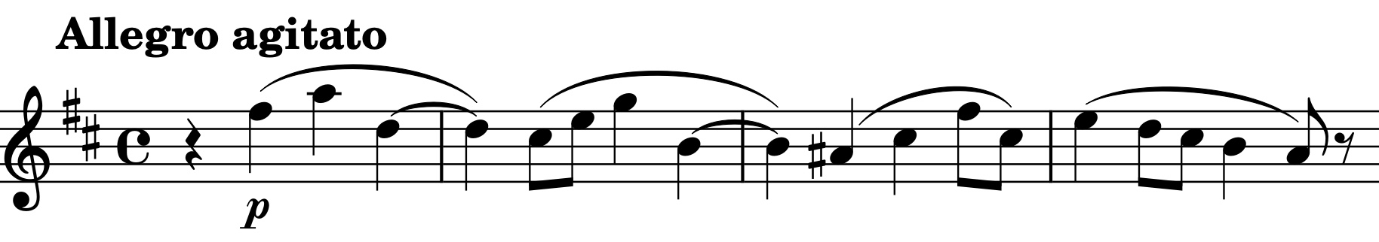
The last movement alternates two different sections. The first is scherzo-like in 3/8 with a theme (illustrated) clearly related to that of the previous movement. The second section is faster, in 4/4, and its syncopated main theme (illustrated) is related to the theme at the start of the first movement.

