Programme notes by Chris Darwin; use freely for non-commercial purposes.

Johannes Brahms (1833-1897) Piano Quartet No. 1 in G minor Op. 25 (1861)
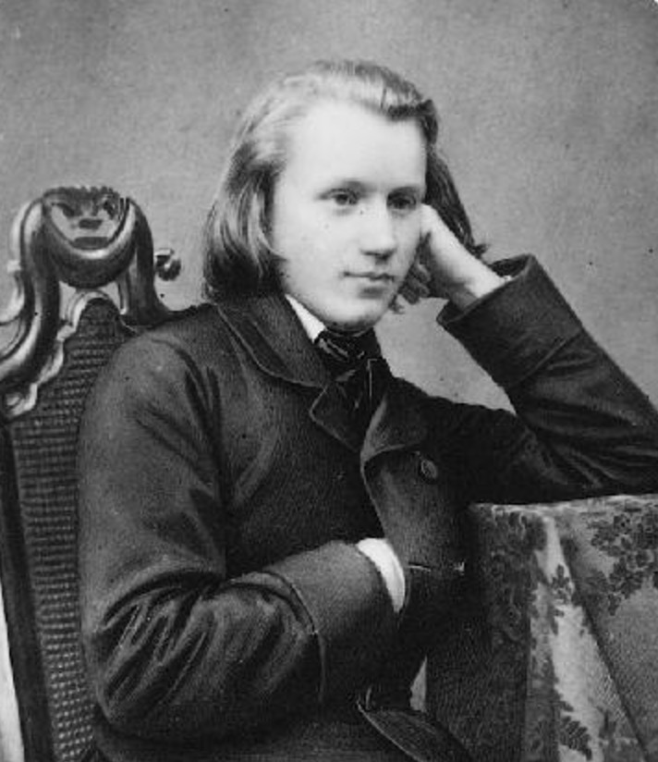
Allegro
Intermezzo: Allegro ma non troppo; Trio: Animato
Andante con moto
Rondo alla Zingarese: Presto; molto presto

In the autumn of 1853 the 20-year-old, well-read, blue-eyed, long fair-haired, slender pianist and composer Johannes Brahms (illustrated) arrived at the home of Robert and Clara Schumann, introduced by the violinist Joachim. As their protégé, Brahms' career flourished, while he in turn not only helped with the household as Robert's illness progressed, but also fell in love with Clara, 14-years his senior (Brahms' mother was 19 years older than his father). After Robert died in 1856, Brahms and Clara decided to go their separate ways but remained close friends. Brahms then found it hard to compose; he wrote to Clara that he felt he no longer knew ‘at all how one composes, how one creates’. However, he recovered, partly thanks to Joachim who provided him with an encouraging exchange of polyphonic exercises; he also studied early music and folksong and conducted the court choir.

By the early 1860s he was composing a string of chamber masterworks: two string sextets, a piano quintet, two piano quartets, a horn trio and a cello sonata. The choice of forms is a break with the classical masters. Neither Mozart nor Beethoven wrote mature string sextets or piano quintets; as for piano quartets, Mozart wrote just the two that defined the genre and Beethoven wrote three in Bonn in his teens (eventually published as WoOs – works without opus numbers). Closer to home Robert Schumann had written both a piano quartet and a quintet. One reason that Brahms and Schumann turned to the larger chamber groups with piano was that pianos had by the 1860s developed the power to stand up to the strength of three or four string instruments. This increased force is certainly exploited by Brahms. His two piano quartets provided a great showcase not only for the piano but also for the strings. Their first performances, in Vienna, were given by Brahms with Joseph Hellmesberger's quartet, itself a showcase for the leader Joseph who billed his group as the “Hellmesberger Quartet, with the assistance of ... [names of the other players] ”.

Unlike Wagner and Liszt, Brahms respectfully and meticulously adhered to classical forms; however, within those tight structures lies much innovation. Schoenberg wrote a chapter on 'Brahms the progressive' and Anton Webern believed that Brahms had anticipated the radical developments of their Second Viennese School. Schoenberg gave tonight’s Op 25 G minor piano quartet the substantial accolade of arranging it for full orchestra. As you listen to the final bars of the piece you might be entertained to imagine them orchestrated by Schoenberg complete with trombone glissandi and a large percussion battery including xylophone and glockenspiel!

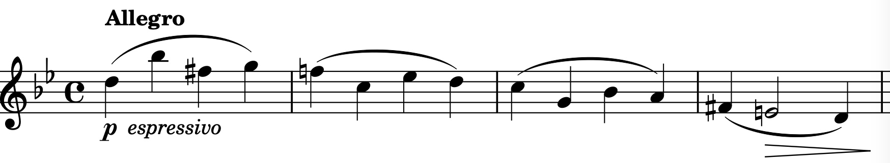
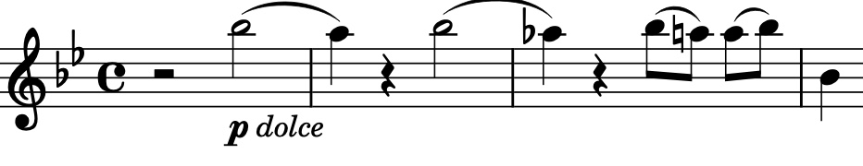
Ivor Keys cites the first subject of the G minor Piano Quartet as an example of Brahms’ use of classical forms. One feature, that mirrors Mozart, is to give the first subject two contrasting parts: the opening 10 bars is a figure in angular unison (illustrated) followed after a significant silence by a second part that is a smoother figure built on a simple change of a tone or semitone (illustrated). Each of these is separately developed in what Schoenberg called 'developing variation'; Brahms makes a series of relatively small changes to themes, gradually transforming them into something new.

The second movement, a Scherzo structure marked Intermezzo, is an ingenious contrast to the movements that flank it. The strings are muted throughout and predominantly play quietly to a 9/8 time signature which embeds a fast three quavers within three slower beats. The result is an intriguing ethereal texture.

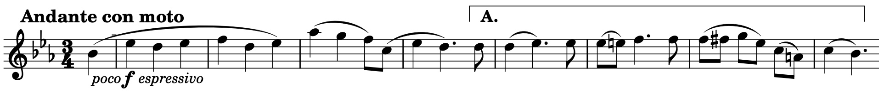
The somewhat grandiose opening theme of the Andante third movement (illustrated) is reminiscent of the first theme of the first movement, and also shares with it a second part (under A) with a similar semitone movement. Brahms produces a splendidly rich texture with the three strings harmonising the theme against a Bach-like moving base in octaves on the piano. A section with an insistent dotted rhythm leads to a slightly faster section with an exaggerated version of the dotted rhythm – a sort of curious march in three-time!

The Presto last movement is titled Rondo alla Zingarese - the ‘Gypsy Rondo’. It captures the style and excitement of the music that Brahms had toured Europe with accompanying Eduard Remenyi, a Hungarian violinist. Brahms mistakenly believed the music was based on the Magyar folk tradition, but it was actually based on the popular version of Hungarian music played by travelling gypsy bands who had no roots in the real Magyar tradition. This tradition was rescued much later by the field work of Bartók and Kodály,
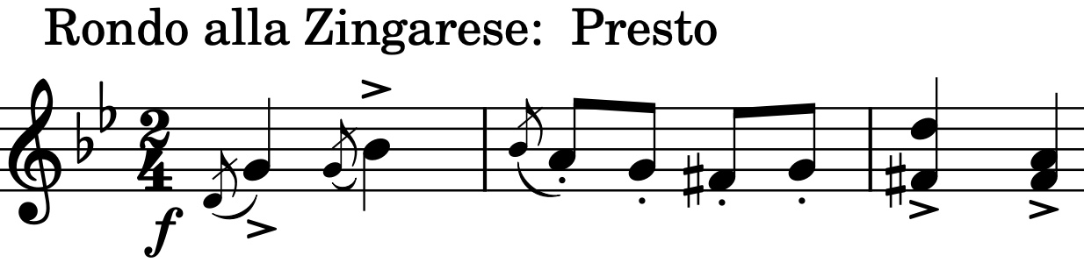
The energy is evident in the heavily accented, forte opening phrase (illustrated) and rarely lets up. A famous passage of very fast, molto leggiero, octave semiquavers on the piano gives the strings a pizzicato respite, before a slower tempo allows the players to bask in a glorious Brahms’ melody. Faster and slower alternate before a cadenza from the piano leads to a manic Molto Presto rush to a roof-raising conclusion.

