Programme notes by Chris Darwin. Please use freely for non-commercial purposes.

Ludwig van Beethoven (1770-1827) Piano Trio in D, Op.70 No.1 (Ghost) (1808)

Allegro vivace e con brio
Largo assai ed espressivo
Presto

1808 saw Beethoven composing at full power: his Fifth and Sixth Symphonies, the Choral Fantasia, the A major cello sonata as well as the two Op 70 piano trios all come from this year. The cello sonata and the piano trios seem to have been part of a conscious decision by him to revisit the chamber music forms with which he had made such an impact shortly after his arrival in Vienna.

Why the 'Ghost' trio? The name was coined by Carl Czerny, pianist, composer, pupil and friend of Beethoven who wrote that the slow movement always reminded him of the appearance of Banquo's ghost in Macbeth. It is not known whether Czerny was aware that Beethoven had included in the sketchbook that he had used for the Ghost Trio preliminary ideas for an opera based on Macbeth. Whether or not Beethoven specifically had Banquo in mind, the trio is certainly dramatic.
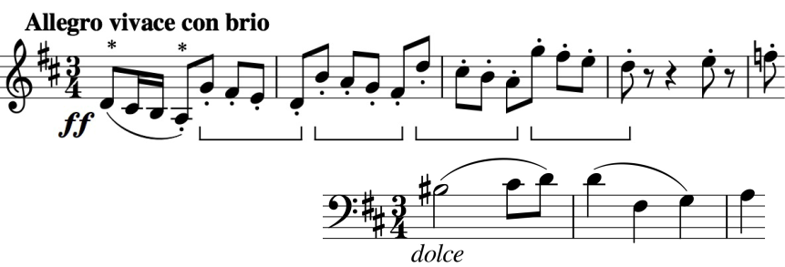

The opening (illustrated) is ferociously violent with groups of four quavers (bracketed) battling with the triple-time key signature. Immediately,

though, the cello presents an 'aching, tender melody' (illustrated); each of its first two bars presents a motif for later development as the movement batters us with conflicting emotions.

The eponymous slow movement is marked Adagio assai – Very slow – and slow it is, I know of none slower in chamber music. In many performances, each crotchet beat takes almost 4 seconds. A consequence of this sepulchral tempo is that in order to get the players to play fast you have to write lots of notes in the bar: just before the end there are shuddering bars that contain 48 separate triplet hemi-demi-semi-quavers ! As Angus Watson points out, these trembling figures are reminiscent of Florestan's despairing aria at the opening of Act 2 of Fidelio, and this movement
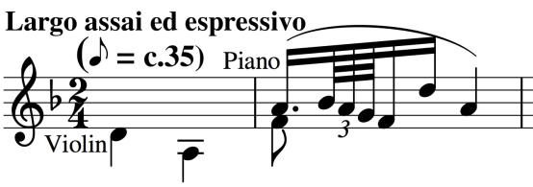
lacks none of its spine-chilling passion. Note that the opening two crotchets (illustrated) D and G are the same notes as the first two crotchet beats in the opening theme of the first movement (*).

The last movement opens expansively and genially, then pauses twice for breath, gathering its strength to lay some of the preceding ghosts.

