Programme notes by Chris Darwin; use freely for non-commercial purposes.

Ludwig van Beethoven (1770-1827) Piano Trio in B flat Op 11 (1797) ‘Gassenhauer’
Allegro con brio
Adagio
Thema: ‘Pria ch’io l’impegno’ & Variations

This genial trio was originally composed for clarinet, cello and piano, although Beethoven included an almost literal transcription of the clarinet part for violin as an alternative. Clarinets were still rather new, and their possibilities and limitations provided an interesting challenge for the composer, but a conventional piano trio would probably sell better. It is one of only a handful of Beethoven’s early works involving wind which rate as serious works. Most are the lighter wind-band Tafelmusik that he rather apologetically sent to publishers when he needed the money. This trio is certainly substantial and benefits from Beethoven’s experience of writing his three Op 1 piano trios two or three years earlier.

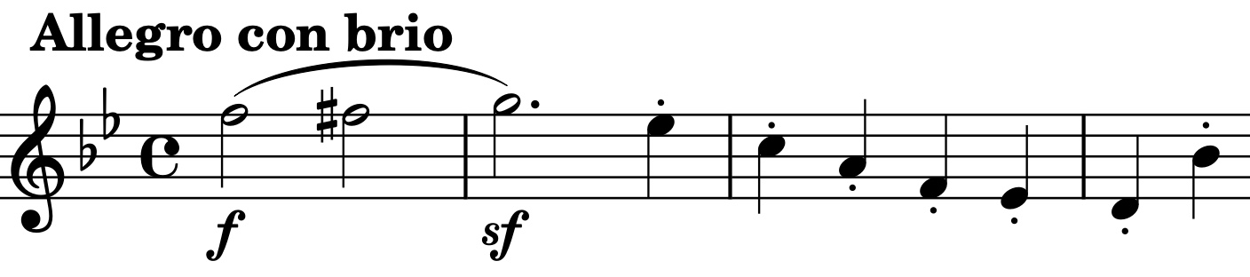
The work is dedicated to Countess Maria von Thun, mother-in-law to two of his patrons – the Princes Lichnowsky and Razumovsky. Angus Watson suggests it might have been a peace offering, since Beethoven could treat the eccentric Countess discourteously: she is reported to have been seen on her knees unsuccessfully begging Beethoven, sat on the sofa, to play for her.

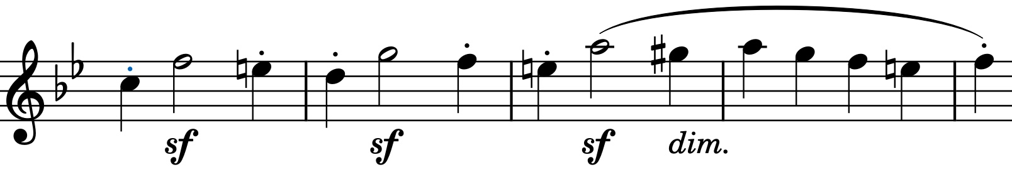
The work is in the clarinet-friendly key of Bb, and the bold opening unison (illustrated) shows off an assertive range of the clarinet (and challenges the substitute violin’s E-string to match it!). The second group of themes has a version of this opening motif whose jaunty syncopation (illustrated) anticipates the theme for the last movement variations.

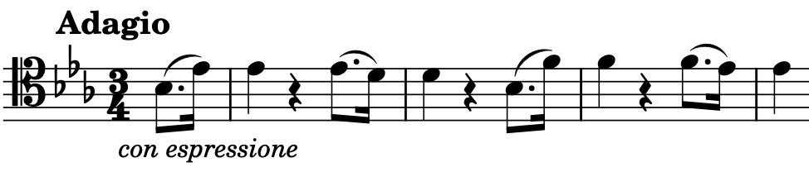
The cello sings the opening theme to the eloquent Adagio (illustrated). It closely resembles the theme of the Menuet of Beethoven’s very successful Septet Op 20 which he wrote two years later and also that of the (‘Easy’) Op 49 no 2 Piano Sonata from 1795.

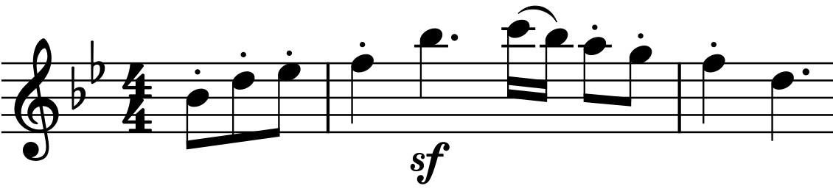
The theme to the last movement (illustrated) was suggested to Beethoven by the clarinetist Josef Berr. It comes from a light opera by Joseph Weigl L'amor marinaro and its words translate roughly as “Before I get down to work, I must have something to eat”. It had become wildly popular, being whistled on the streets - a Gassenhauer (a popular hit or earworm today). When Beethoven realised this, he toyed with substituting a theme of his own, such was his fear of his music becoming popular.

My debt to Angus Watson for my plundering his “Beethoven’s Chamber Music in Context” is gratefully acknowledged.

