Programme note by Chris Darwin. Use freely for non-commercial purposes

Ludwig van Beethoven (1770-1827) Sonata No. 3 in A, Op. 69 (1808-9)

Allegro, ma non tanto
Scherzo. Allegro molto - Trio
Adagio cantabile - Allegro vivace

Beethoven's five cello sonatas cover all three of his major creative periods: the first two (Op 5) were written when he was a young piano virtuoso of 25, tonight's third, Op 69, is from his 'middle' period while the two Op 102 cello sonatas mark the start of the 'late' period.

The A major sonata was composed at a similar time to the 5th Symphony and immediately before the 6th Symphony and the Op 70 Piano Trios (which include the Ghost). It is perhaps the most important cello sonata ever written, expanding both the technical demands on the cello and the subtle complexity of its interactions with the piano.

The equal status of the two parts is evident from the start with the piano daring to continue the cello's glorious solo opening theme (illustrated) and then repeating the opening with the cello taking over.
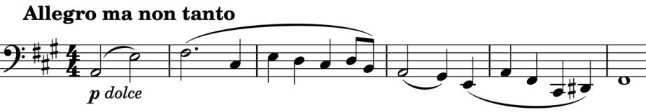
Each instrument rejoices in a brief cadenza to celebrate receiving the succesful handover.

This extended theme provides most of the material for the rest of the movement.
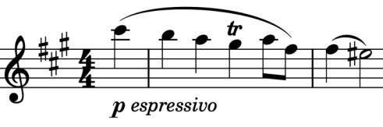

Angus Watson draws attention to a similarity between a subsequent poignant version (illustrated) of the middle section of the above example and the viola da gamba introduction to the alto aria 'All is fulfilled' from Bach's St

John Passion. We don't know whether this link was intentional, but Beethoven wrote 'Amid tears and grief' on the copy of this sonata that he gave to its dedicatee, Ignaz von Gleichenstein, a close and generous friend and excellent amateur cellist. He was perhaps referring to the recent death of Julie von Breuning (née Vering), the young (19-y.o.) daughter of Beethoven's doctor and the recent wife of his childhood friend Stephan. Beethoven was very fond of Julie, had enjoyed playing piano duets with her and was devastated by her death.

After a deeply troubled Scherzo with insistent syncopation and violent contrasts, the Adagio opens with a beautiful serene melody that promises to be the start of something wondrously long, but after a mere 18
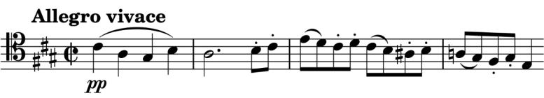
bars, Beethoven thumbs his nose and whisks us off into the glorious sunshine of the last movement
(illustrated). The boisterous high spirits do pause though in a wonderful moment of mutual
tenderness and reflection
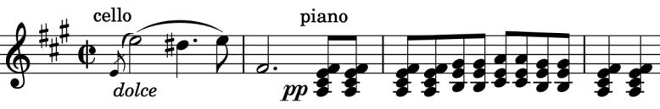
(illustrated).

