Programme Notes by Chris Darwin. Use freely for non-commercial purposes.

Béla Bartók (1881-1945) String Quartet No 5 BB110 (1934)

Allegro
Adagio molto
Scherzo: alla bulgarese
Andante
Finale: Allegro vivace

Elizabeth Sprague Coolidge inherited substantial wealth from her Chicago-based wholesale-dealer father. She used it most generously and effectively to encourage the writing and performing of chamber music: auditoriums in Washington and New Haven, the Coolidge medal for services to chamber music and the Tanglewood Festival all sprang from her support, along with directly commissioned new works. Bridge, Britten, Poulenc, Prokofiev, Ravel, Schoenberg, Stravinsky all received commissions, as indeed did Bartók. He had been recommended to her by the Pro Arte Quartet, themselves supported by Coolidge. Bartok's Fifth String Quartet was the result, composed in just one month in 1934 and premiered in the Coolidge Auditorium in April 1935. Bartók had toured the States on a two-month concert tour in the winter of 1928-29, and finally emigrated there with his wife in 1940.

1934 saw the start of a new phase of Bartók's life. Dohnányi's appointment to be head of the Budapest Academy of Music in the summer of 1934 allowed Bartók to realise a long-held ambition to transfer to a position in enthnomusicology in the Academy of Sciences.
The post allowed him to devote himself to a ‘complete, rigorously critical and exact publication’ of Hungarian folk music, in collaboration with Kodály, with whom he had collected about 14,000 items. Release from his everyday music teaching lead to a golden period of composition. Four major chamber works were written between 1934-39: the last two string quartets (nos 5 & 6), the Sonata for two pianos and percussion, and Contrasts for clarinet, violin and piano. His folk-music collecting provides rhythmic and melodic material for the fifth quartet. For example, the third movement has one Bulgarian time signature - 9/8 grouped as (4+2+3) - for the Scherzo, and another - 10/8 grouped as (3+2+2+3) - for the Trio.

The fifth quartet, though chromatic, has a melodic and tonal flavour that comes from Bartók's 'melodic new chromaticism'. With this, as reported by Yehudi Menuhin, Bartók ‘wanted to show Schoenberg that one can
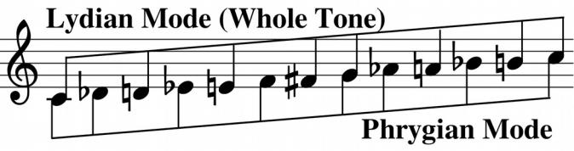
use all 12 tones and still remain tonal’. By interleaving the notes from two different modes (the whole tone Lydian mode and the Phrygian) he could use all 12 tones but preserve a common base (illustrated).

Bartók was also fascinated by different structural symmetries. At the largest scale the Fifth Quartet is an arch shape, centred around a Scherzo & Trio. But within this arch is a wealth of different structures. For instance, the first movement is itself an arch: the different sections of the exposition are played in the recapitulation in reverse order, and also inverted in pitch. The last movement is also arch-like: ABCB'A' plus a final coda. Between these movements are two slow movements in Bartók's 'night-music' style. In addition, the keys of the different sections progress through a whole-tone scale: the exposition is in B♭, C and D; the development is in E; and the recapitulation is in F♯,

A♭and B ♭. The whole tone scale contains the tritone, which is a particularly important interval in this quartet: it divides the octave symmetrically into two equal halves.

Despite all these erudite constructions, the work is a captivating emotional roller-coaster. You never know what is coming next. For example (spoiler alert!), just before the end of the last movement there is a bizarre
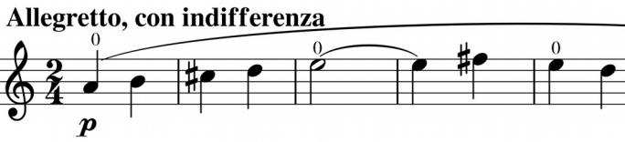
episode: marked Allegretto, con indifferenza. The second violin plays a simple rising tune (illustrated) whose banality is emphasised by the barrel-
organ style accompaniment. No one quite knows who is the target of its unexpected irony.
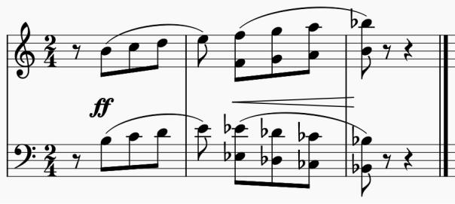

The very definite ending (illustrated) gives a final symmetric twist, with the contrary-motion scales inverting one another.

And all this in just a month!

